**SAMPLE RUN**

**Frame 1 :**

User need to LOGIN or SIGN IN to their account. For new user, they need to click “SIGN UP” button to create an account and “RESET” button is for user to clear all the details that already input in text field.

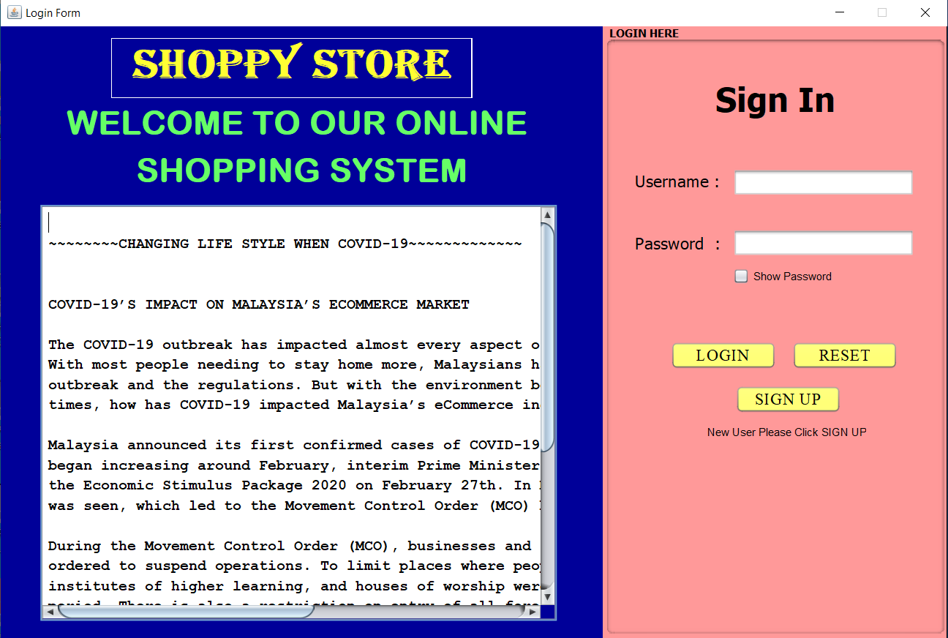

After user click “SIGN UP” button, if the login file do not have any record, it will show this message and user just need to click “OK” button. After that, will go to the registration frame.

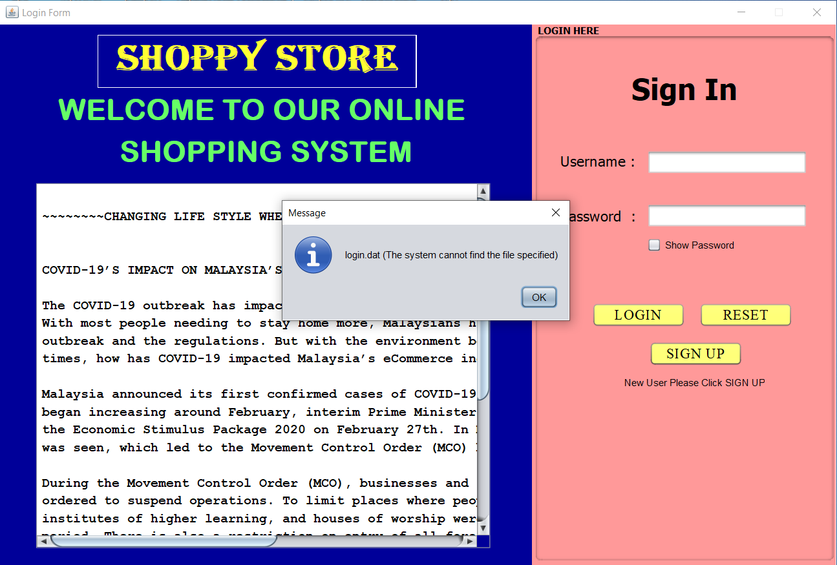

**Frame 2 :**

This frame is registration form.

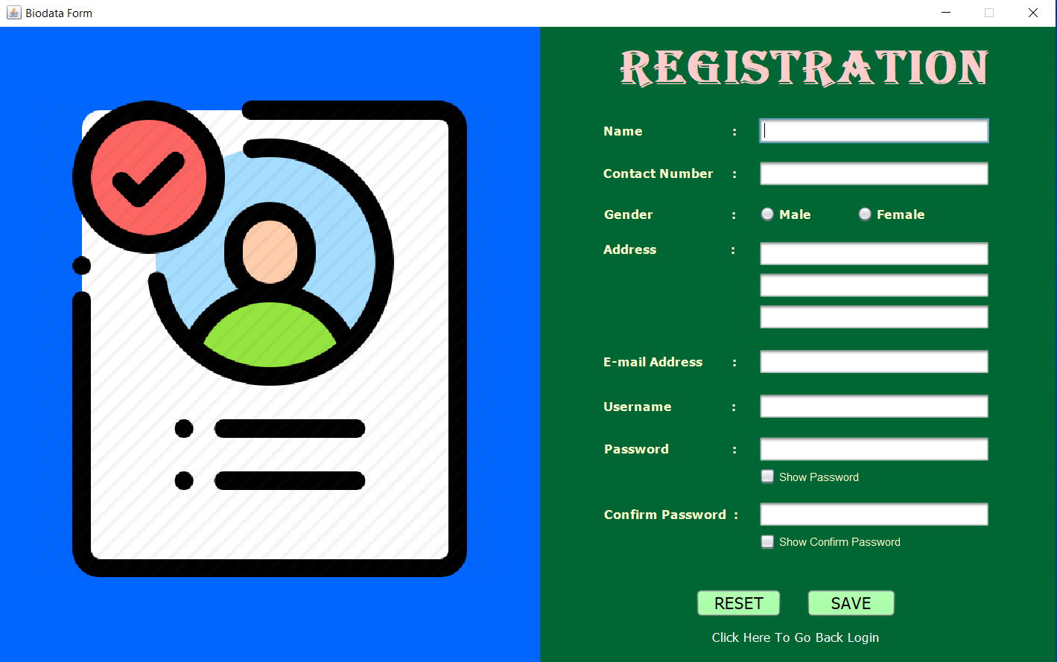

User need to input all the text field, if not user will not register successful.

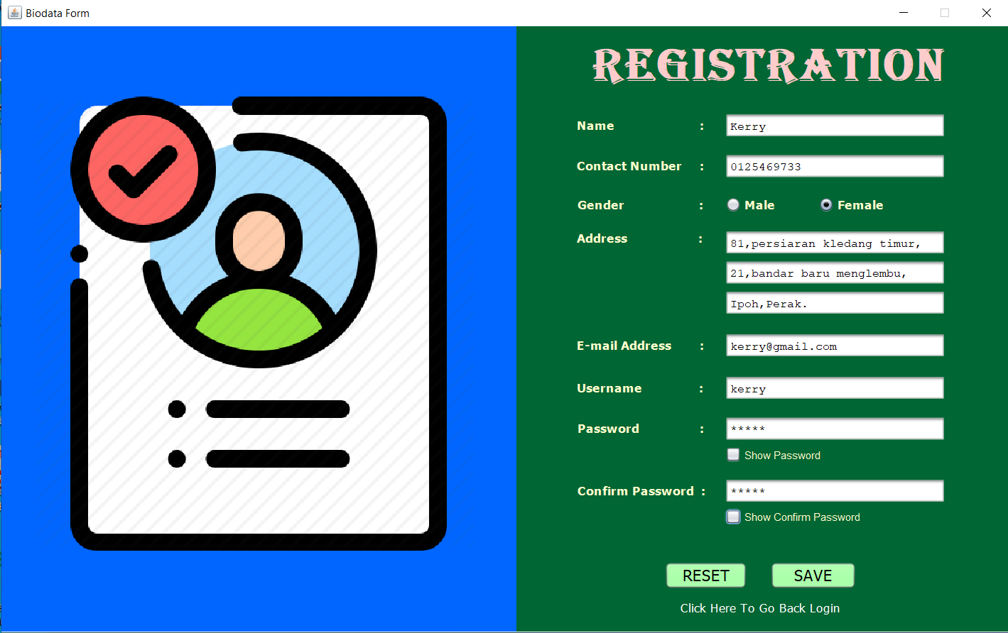

When user input the password and confirm password, user can click the checkbox to check the password and confirm password is match or not.

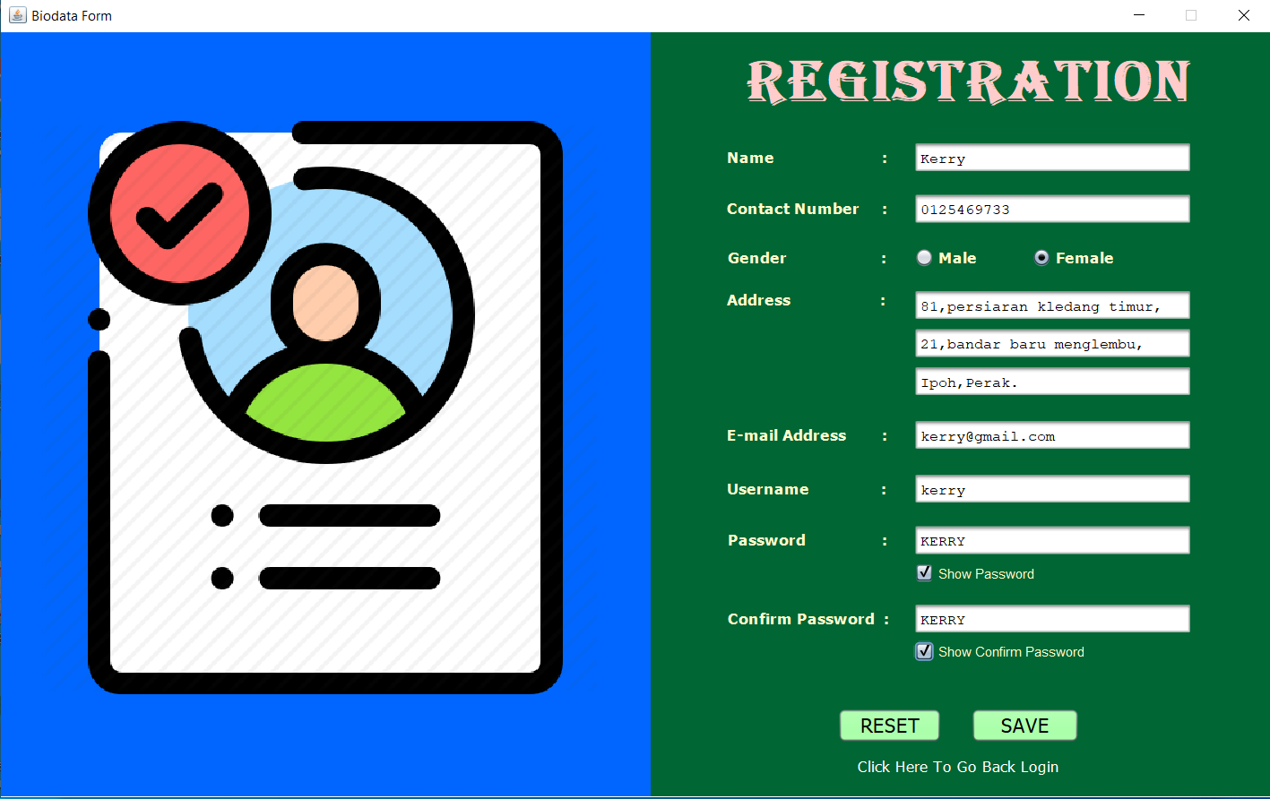

If user input password and confirm password is not match, it will show a message and ask user input again the password.

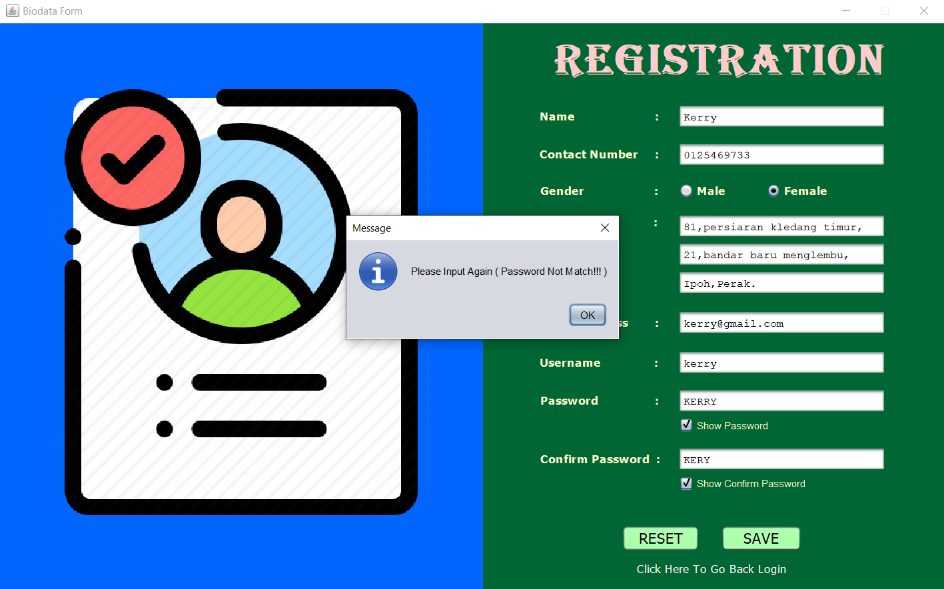

After finish input all the details and click “SAVE” button. It will show this select an option. User need to check the personal details and the important thing is user need to remember their username and password. Then, user can click “YES” button.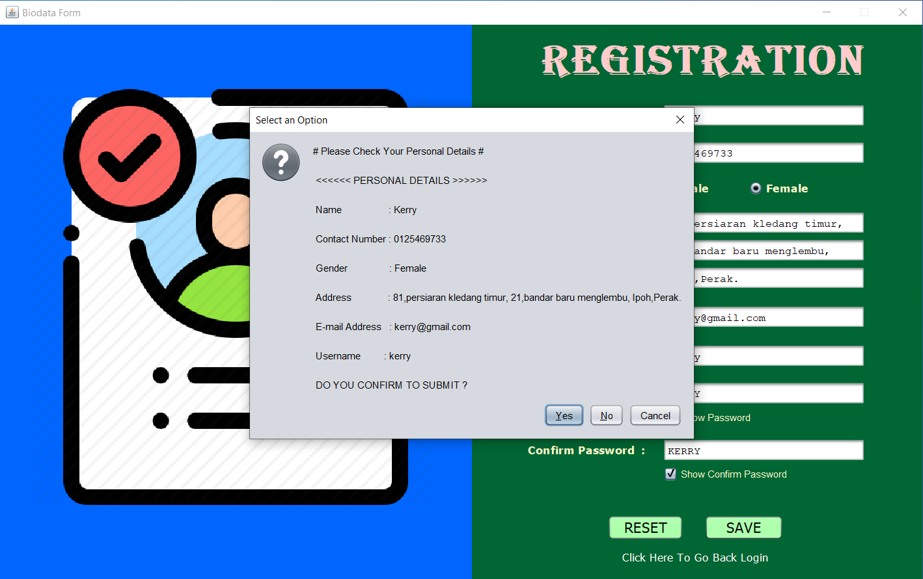

Next, will show this message “REGISTER SUCCESSFUL!!!”. User need to click “OK” button and this registration frame will dispose and will go back to login frame.

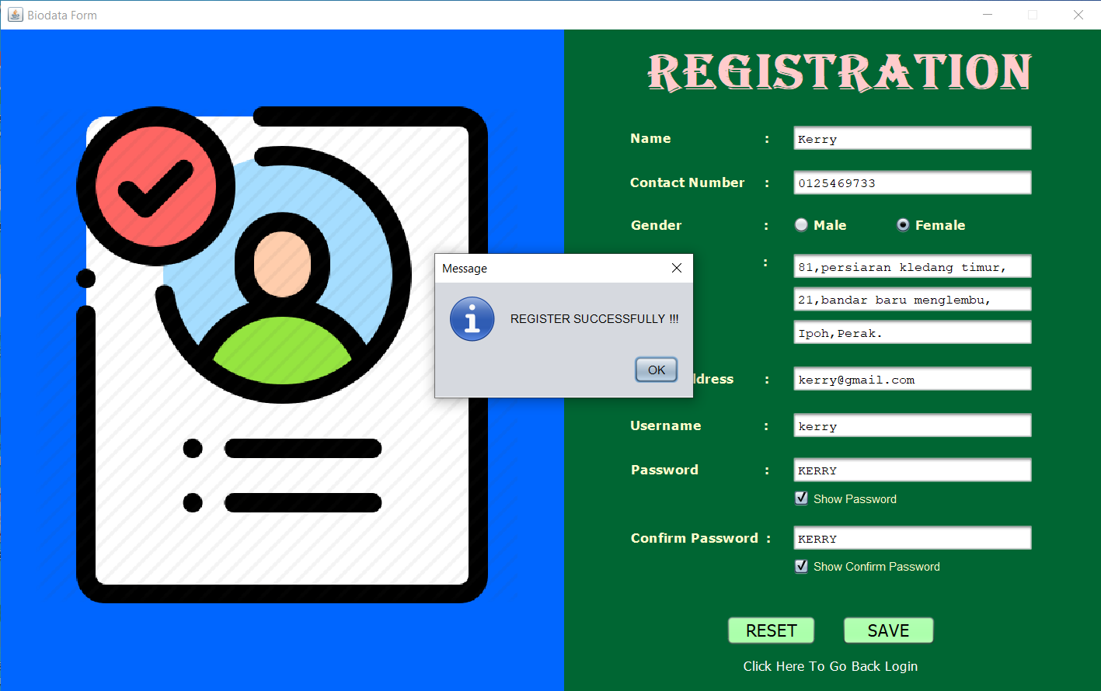

After, new user register successful, new user need to sign in to their account.

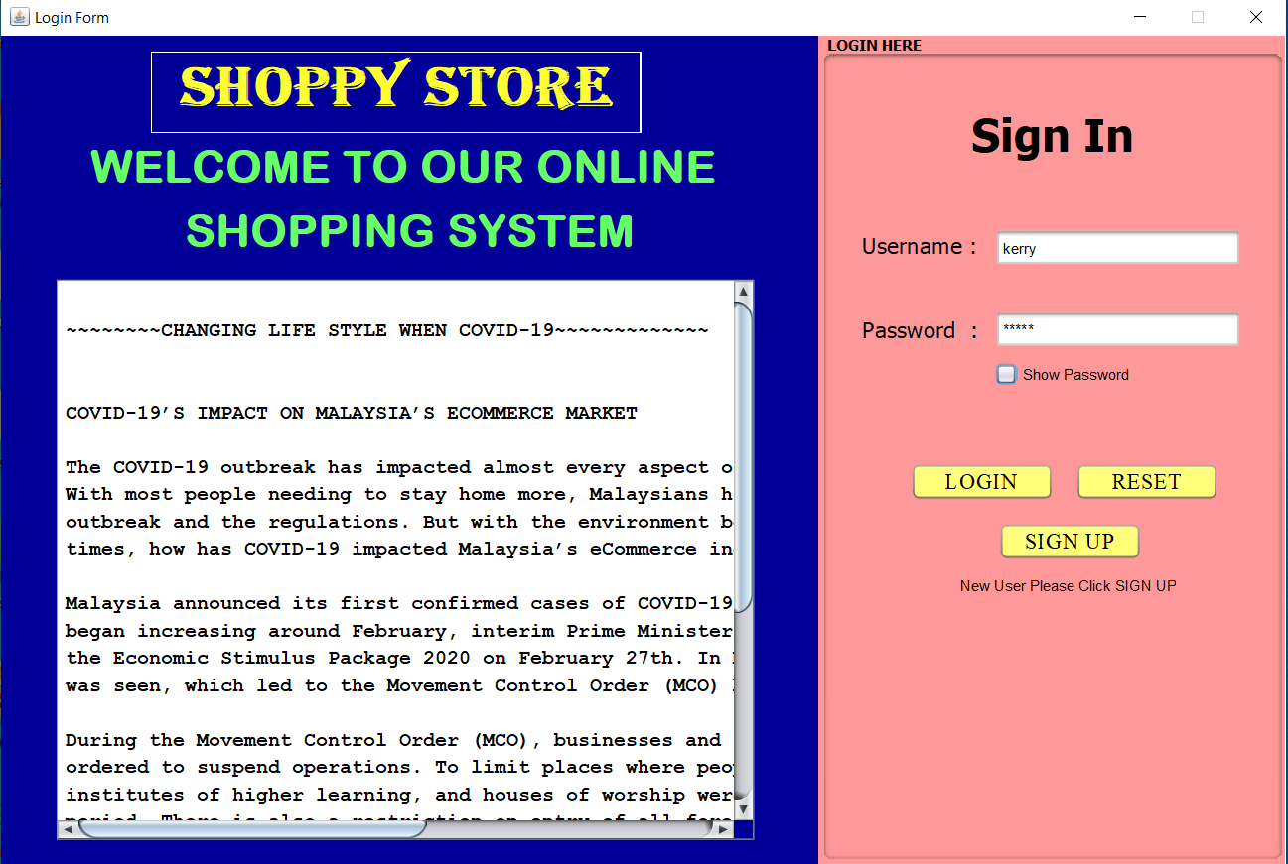

If user input wrong username or password, user will receive this message “Invalid Username or Password”. User need to click “OK” button and input again the correct username and password.

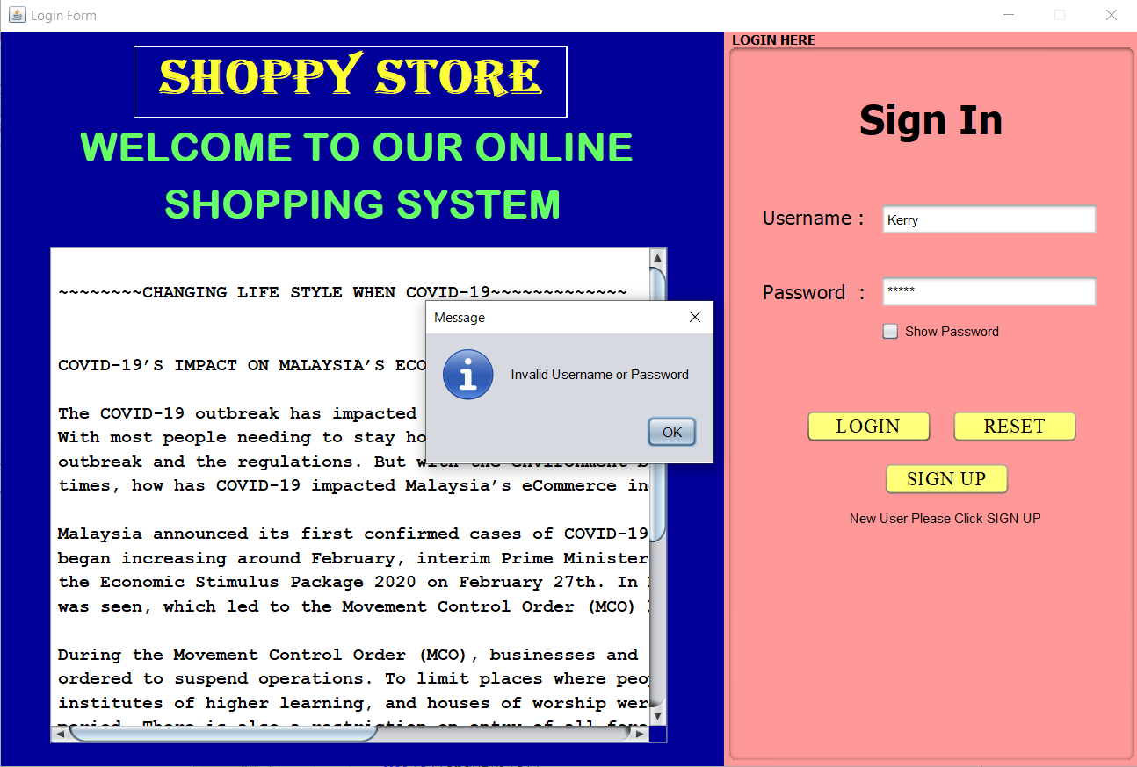

User can click the check box and check the input password.

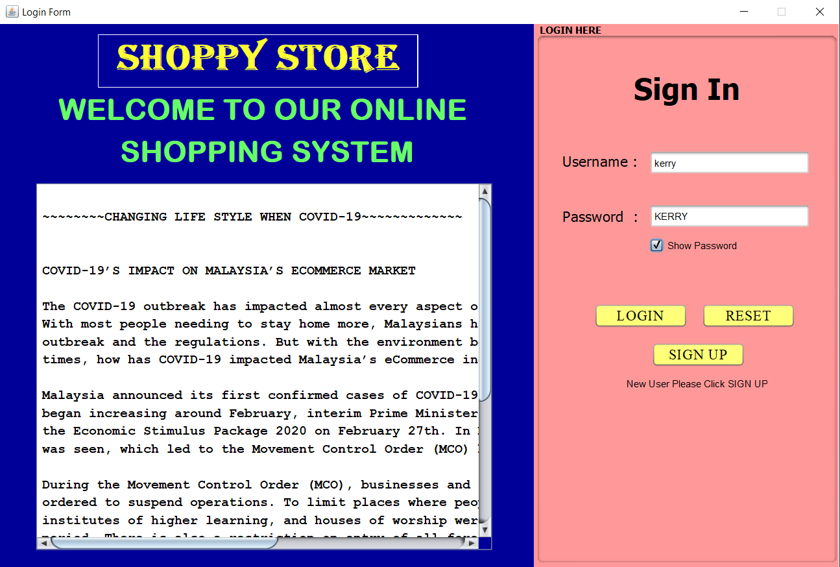

When user input the correct username and password, user will receive a message “Login Successful!!!” and user need to click “OK” button to go to the next frame.

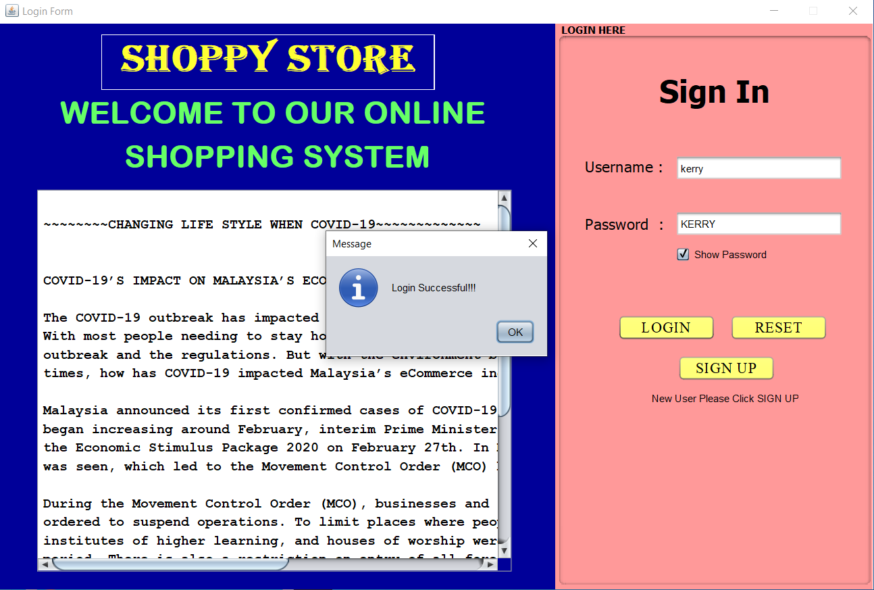

**Frame 3:**

This frame has shown the product categories for life style. User can choose the category and click the button with the category name has shown there.

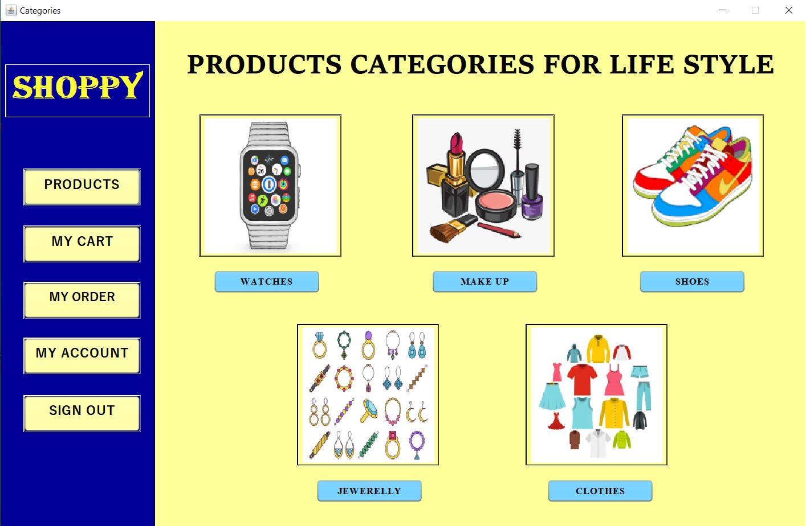

**Frame 4:**

If user click “WATCHES” button, it will come to this frame and user can know more about the watch products by reading the information have given. After finish reading, user can click “SHOP NOW !!” button.

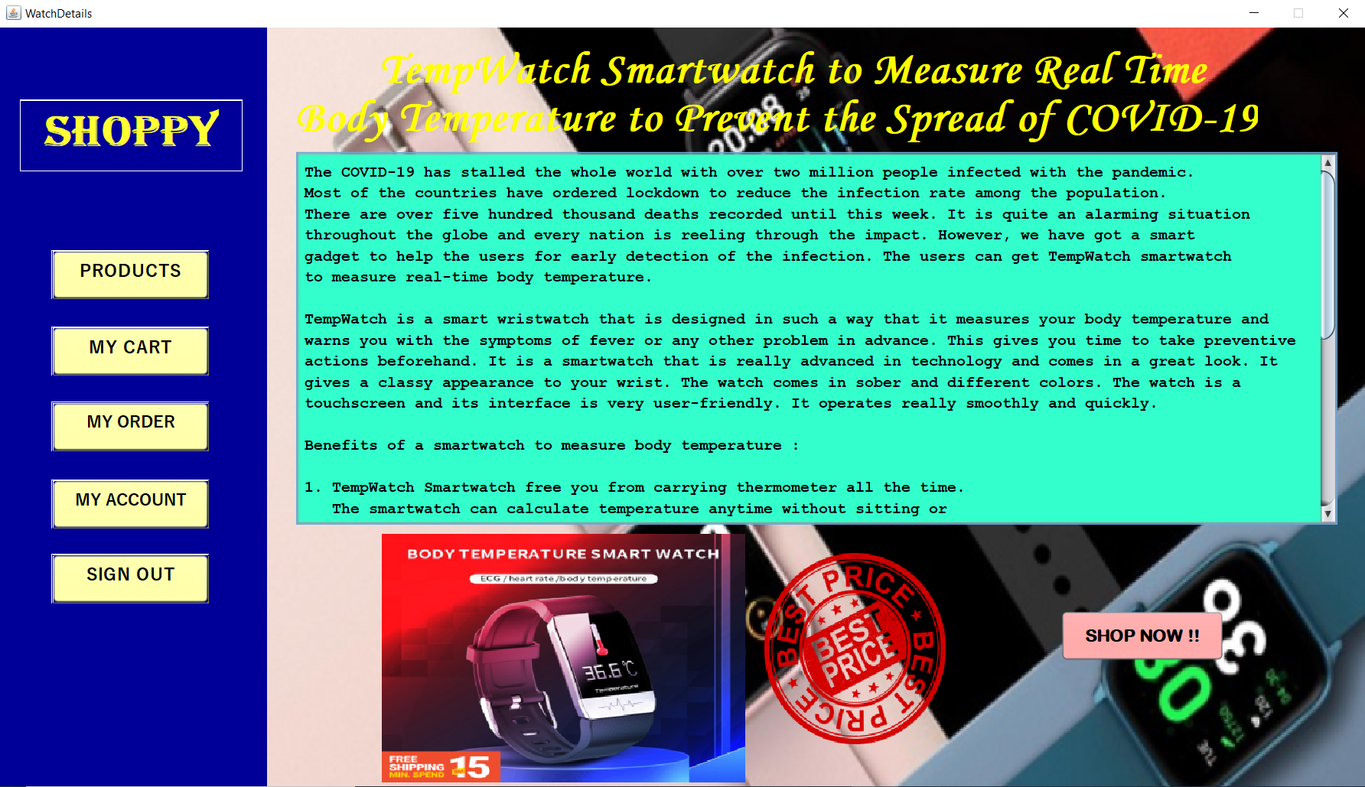

**Frame 5:**

After click “SHOP NOW!!” button, this watch catalogue frame will show. There are 8 watch products. User can know more about the product’s specification and feature by click the “VIEW ABOUT PRODUCT” in each product.

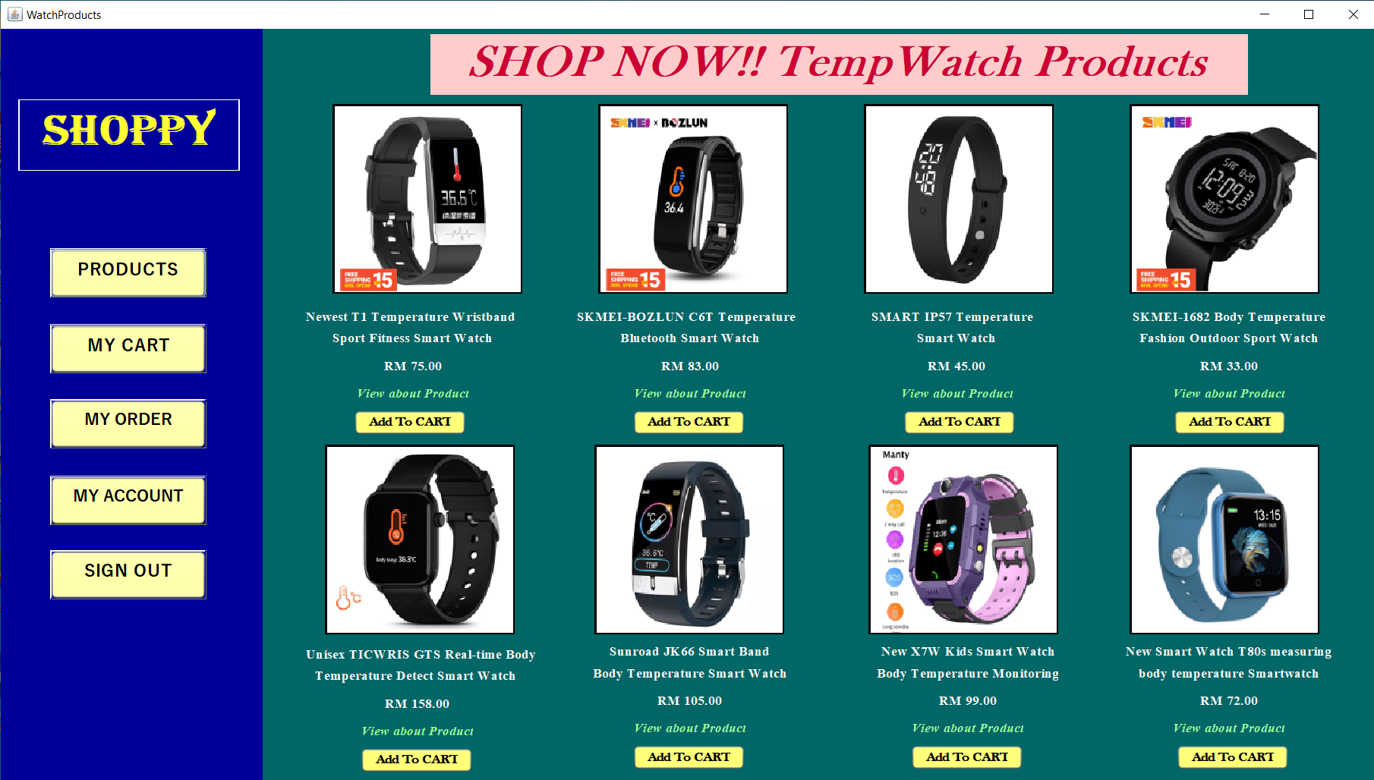

**Frame 6:**

User can know more about watch products by reading the information. After finish reading user can click “X” and go back watch catalogue frame.

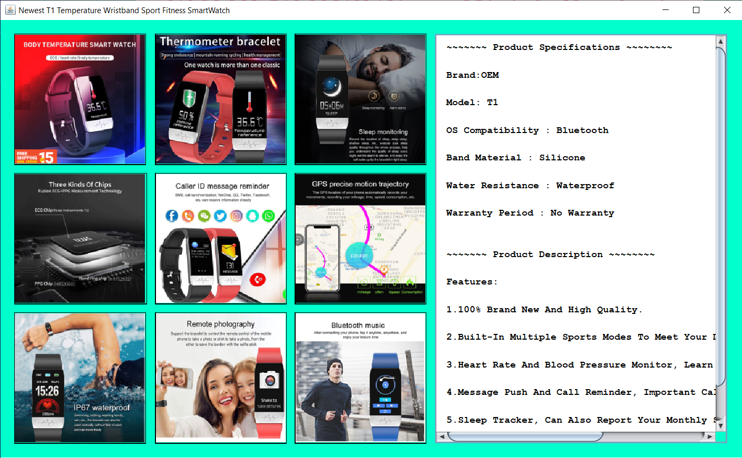

**Frame 7:**

User can know more about watch products by reading the information. After finish reading user can click “X” and go back watch catalogue frame.

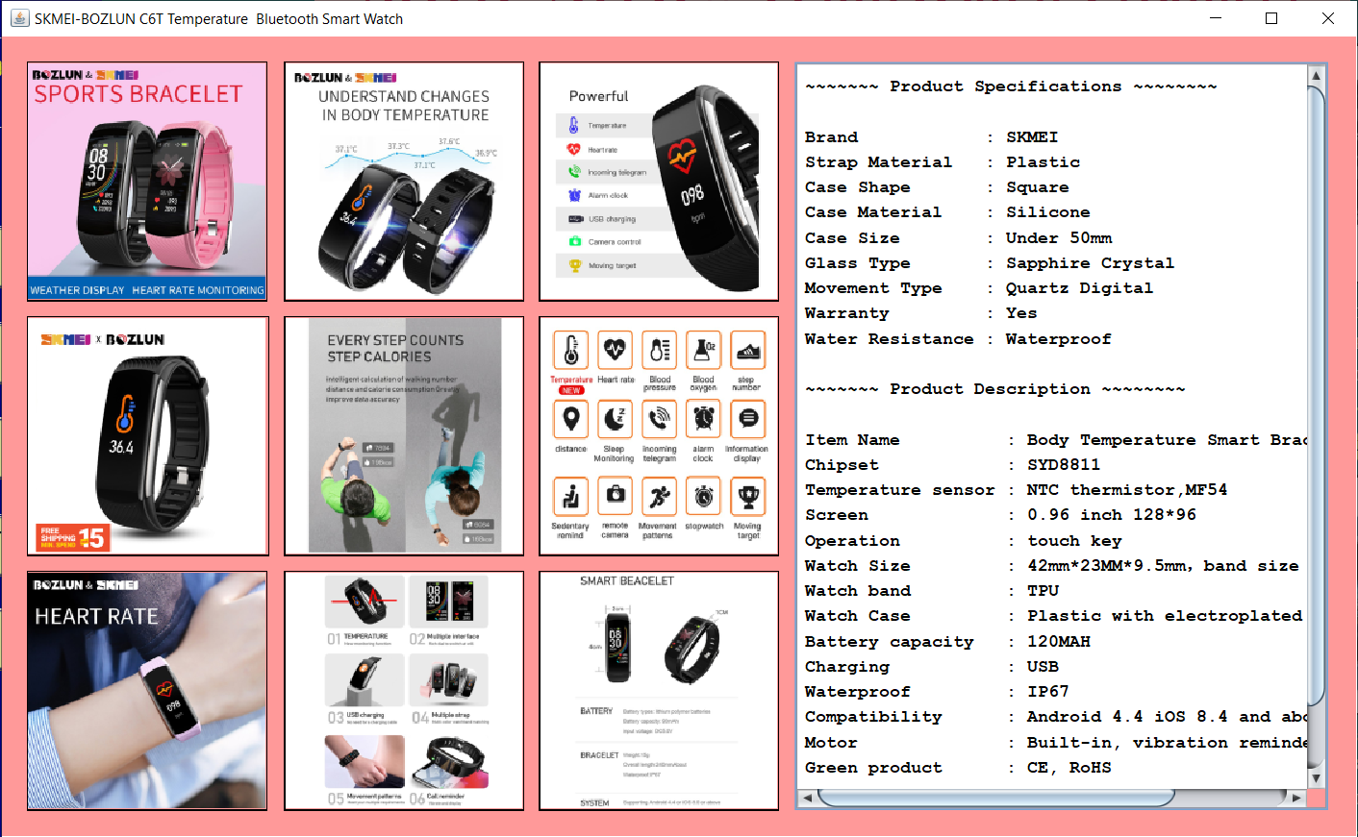

**Frame 8:**

User can know more about watch products by reading the information. After finish reading user can click “X” and go back watch catalogue frame.

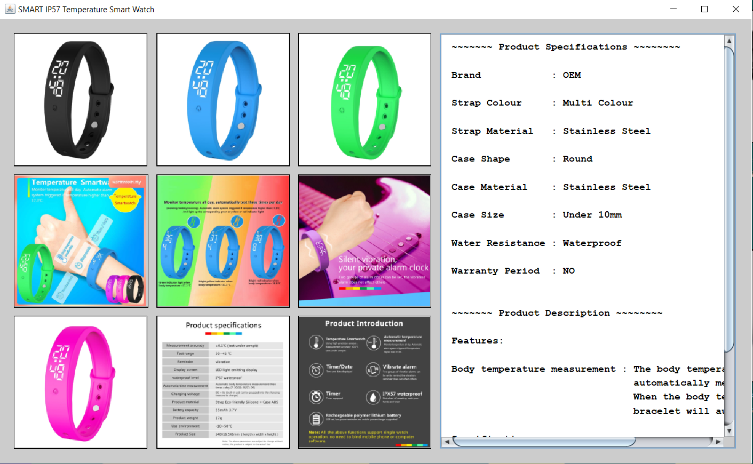

**Frame 9:**

User can know more about watch products by reading the information. After finish reading user can click “X” and go back watch catalogue frame.

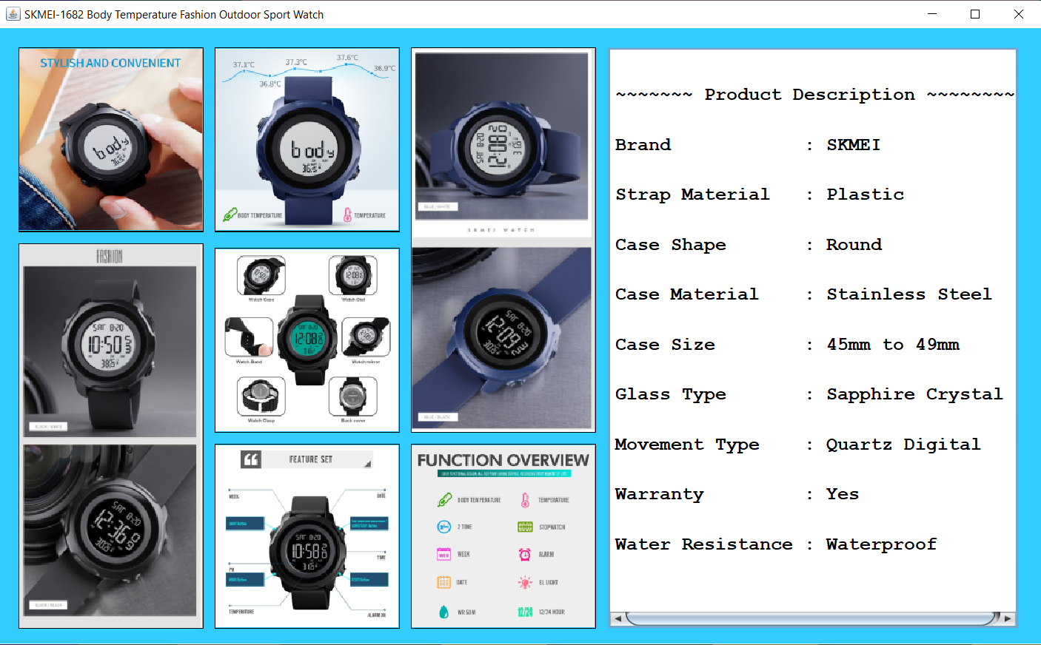

**Frame 10:**

User can know more about watch products by reading the information. After finish reading user can click “X” and go back watch catalogue frame.

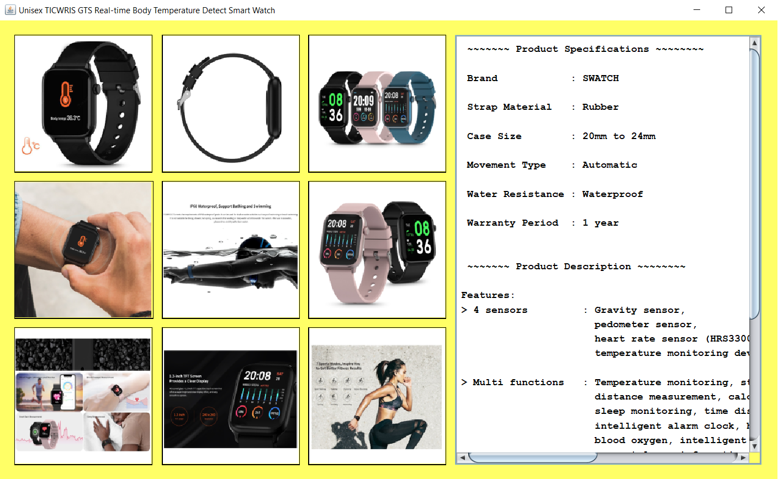

**Frame 11:**

User can know more about watch products by reading the information. After finish reading user can click “X” and go back watch catalogue frame.

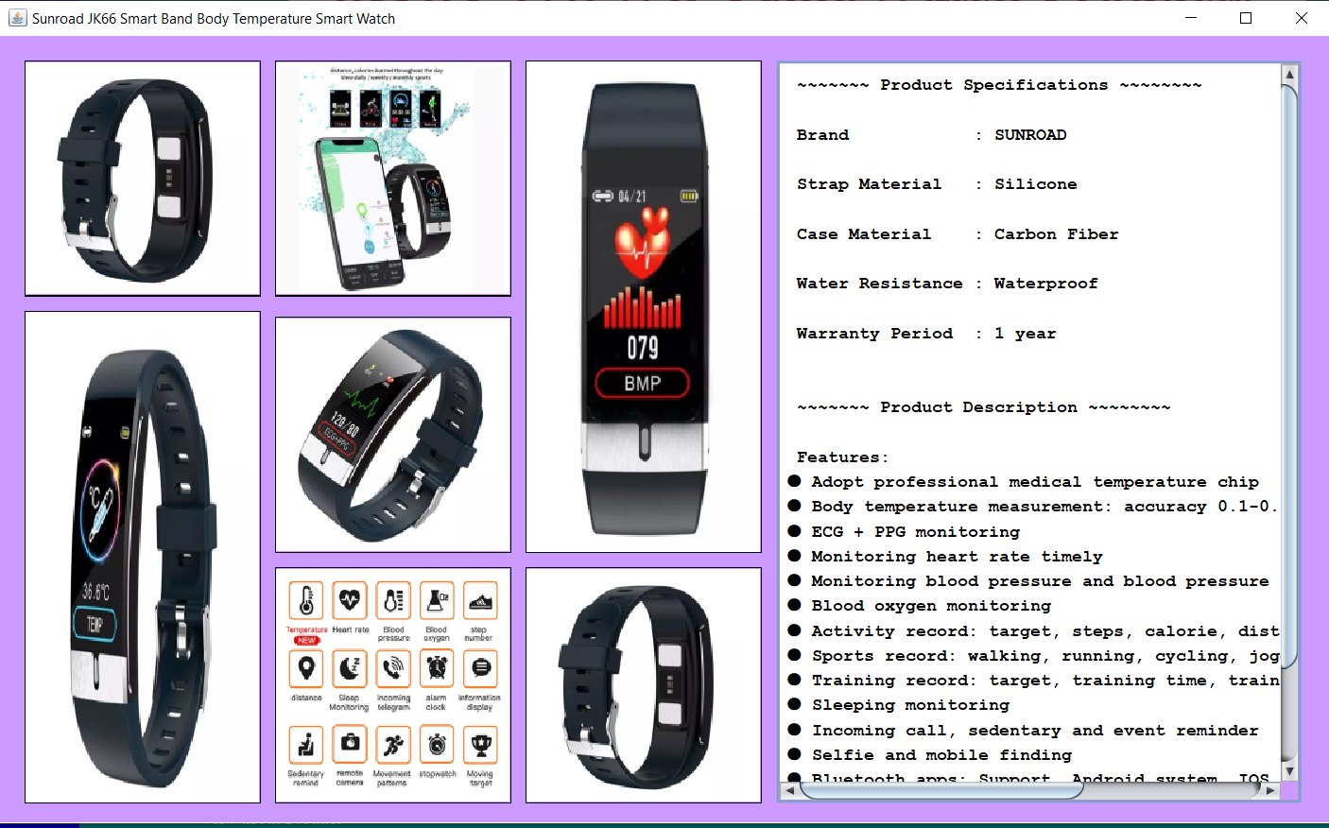

**Frame 12:**

User can know more about watch products by reading the information. After finish reading user can click “X” and go back watch catalogue frame.

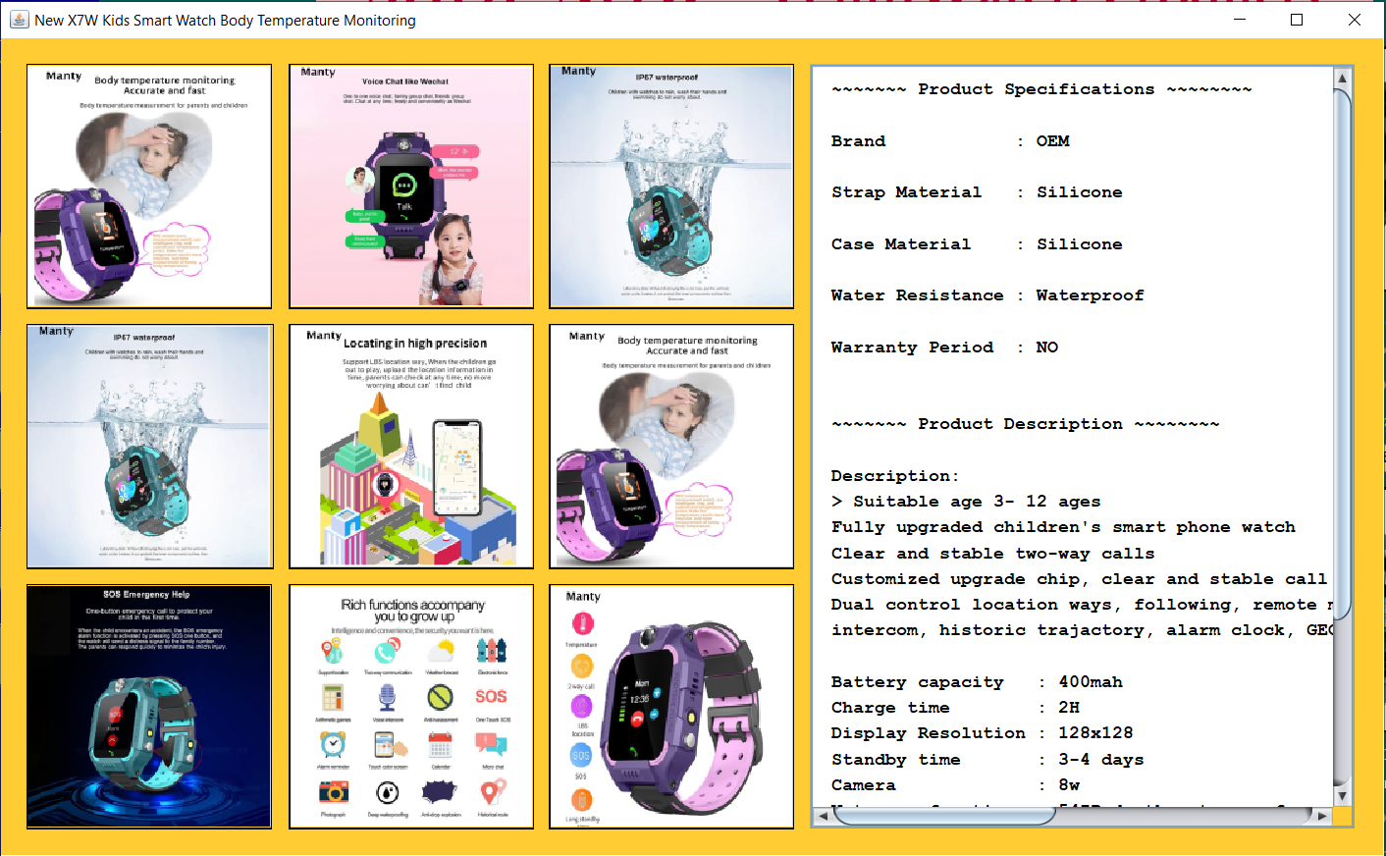

**Frame 13:**

User can know more about watch products by reading the information. After finish reading user can click “X” and go back watch catalogue frame.

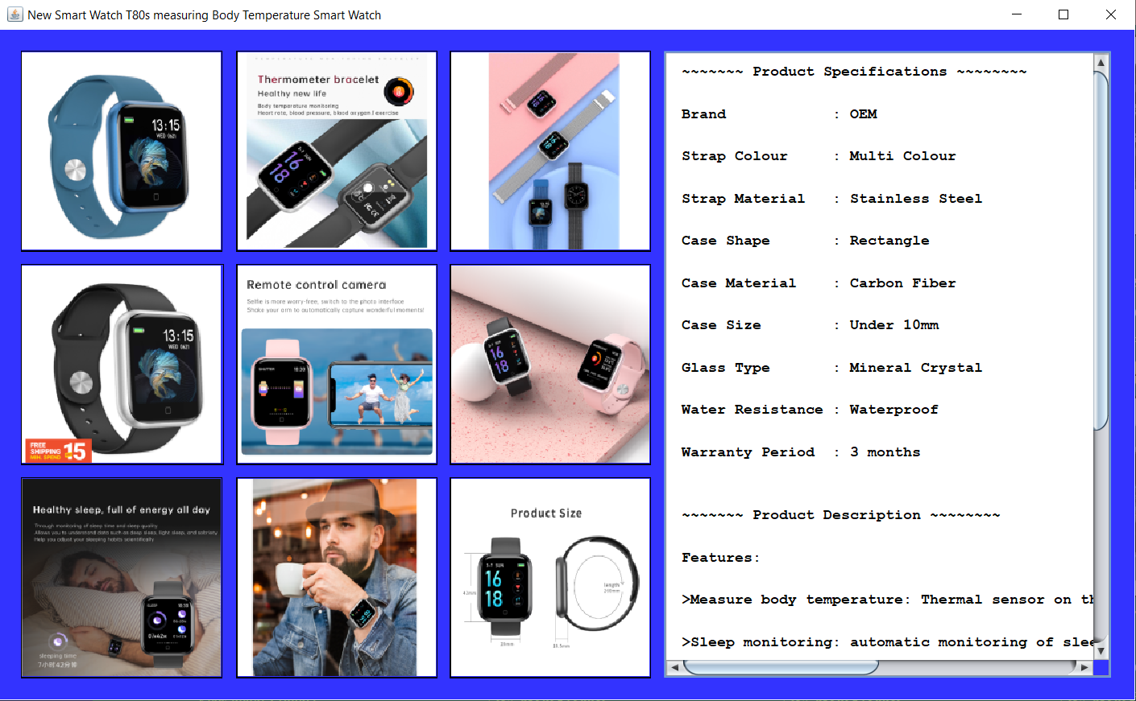

After finish view the products, user can click “Add To CART” button to select the products. Next, user need to input the quantity and select the color. Finish input quantity and select color, user can click “OK” button. When user finish add products, user can click “PRODUCTS” button go back categories frame to choose another categories to add products.

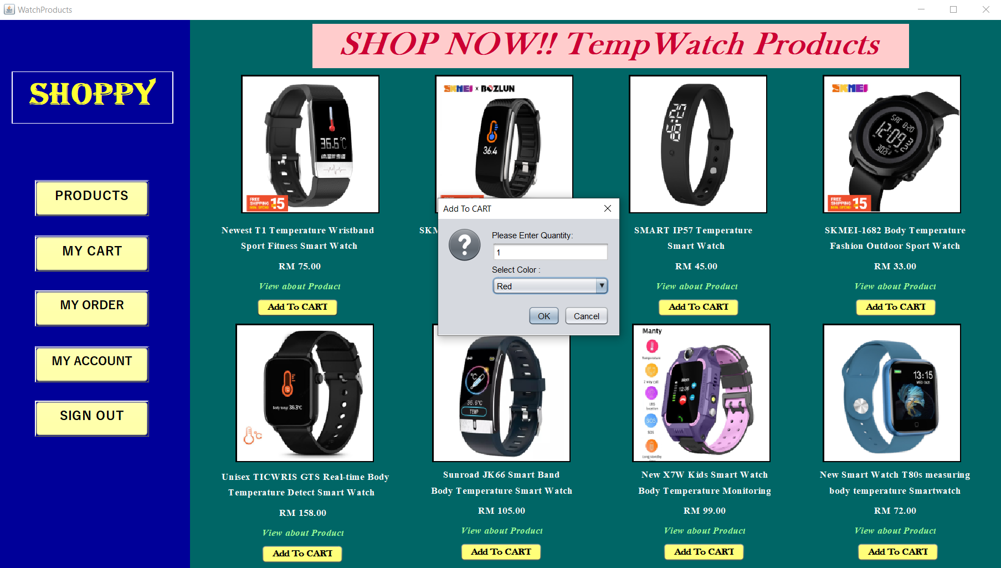

**Frame 14:**

When user click “MAKE UP” button in the categories frame, the catalogue of MakeUp products frame will show.

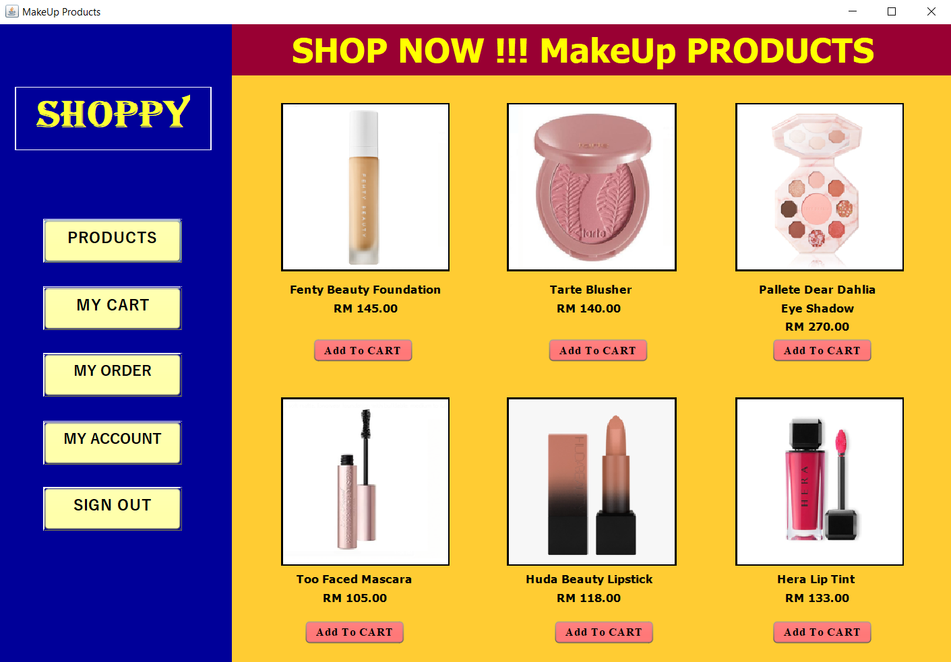

User can click “Add To CART” to select the MakeUp products. Then, user need to input quantity and click “OK” button.

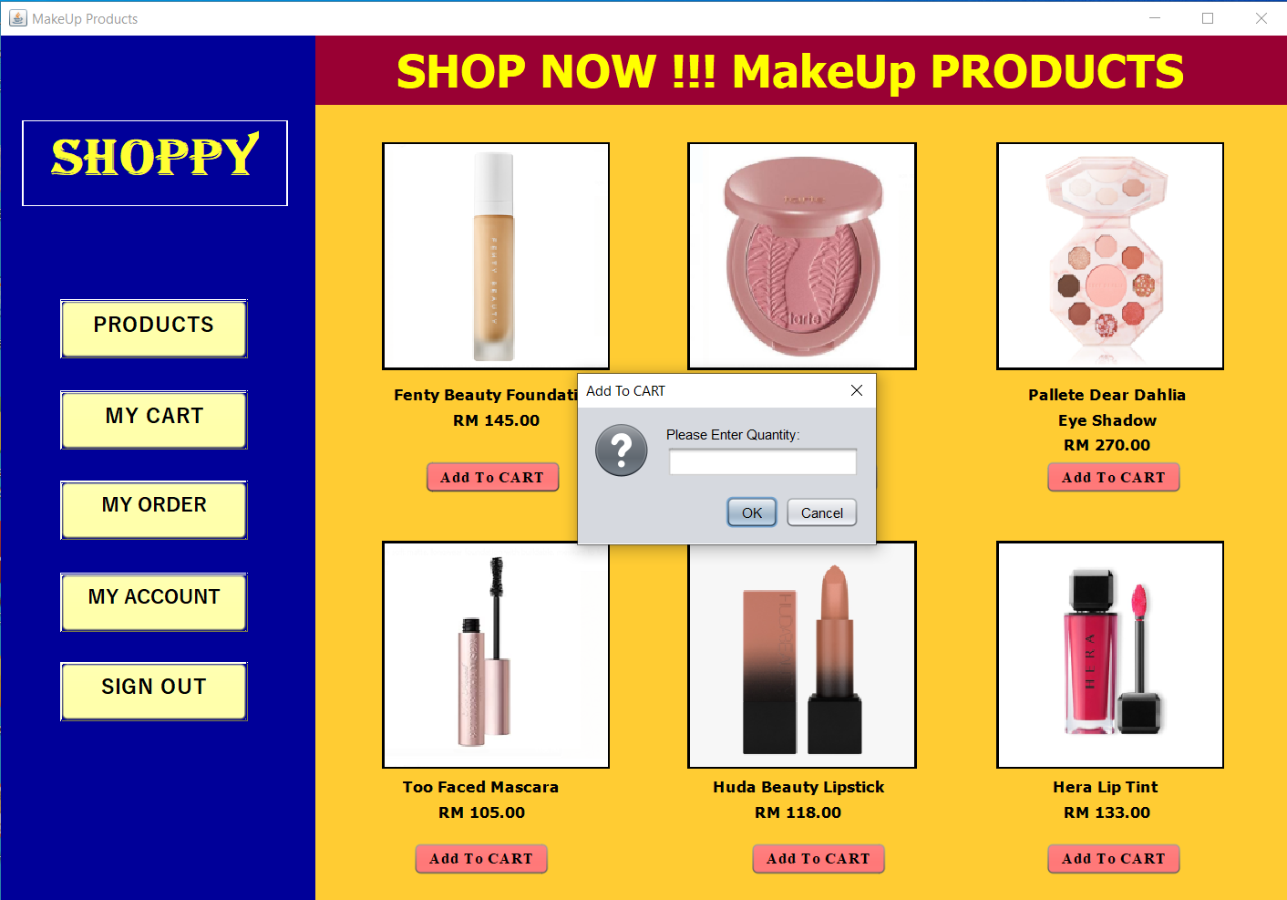

**Frame 15:**

When user click “SHOES” button in the categories frame, the catalogue of Shoes products frame will show.

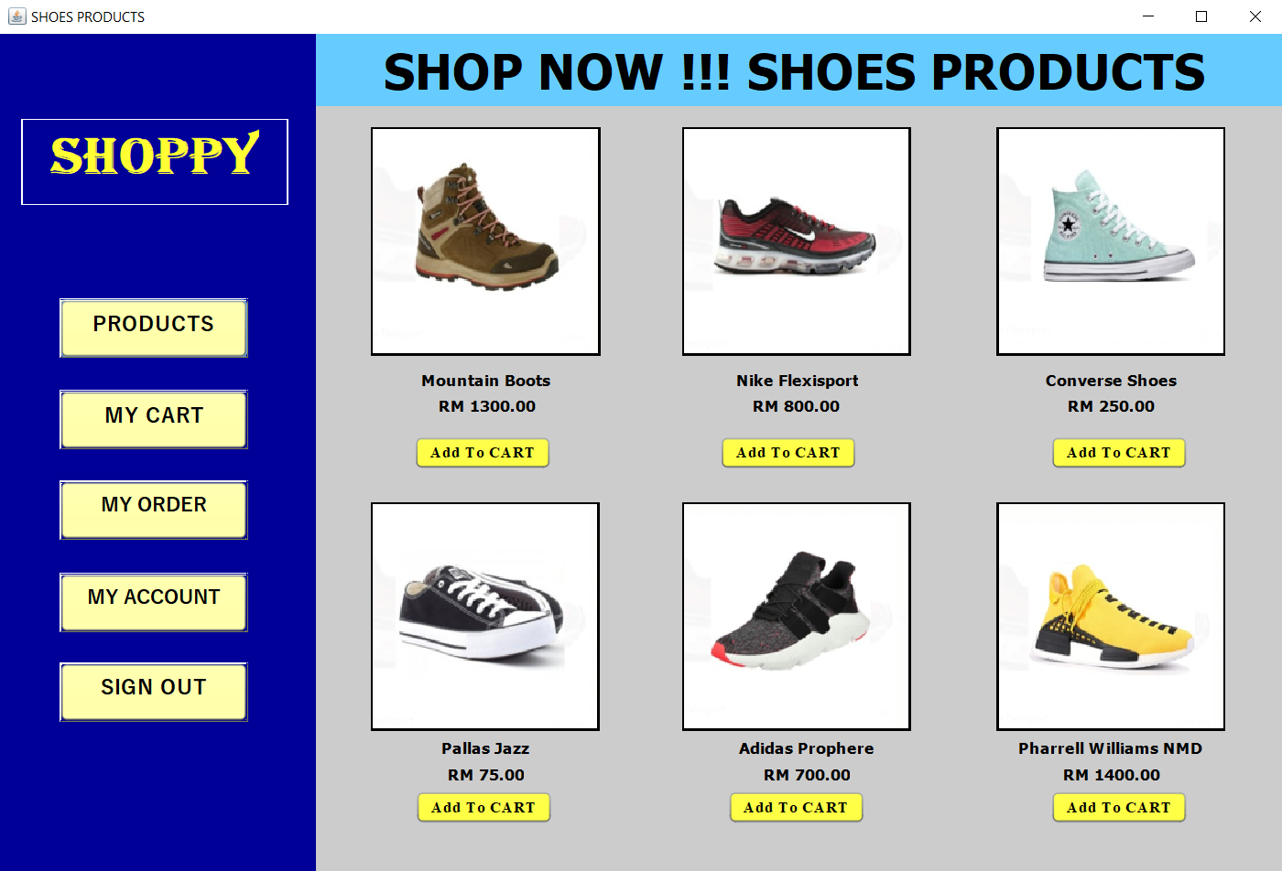

User can click “Add To CART” to select the Shoes products. Then, user need to input quantity, select color and size of shoes and click “OK” button.

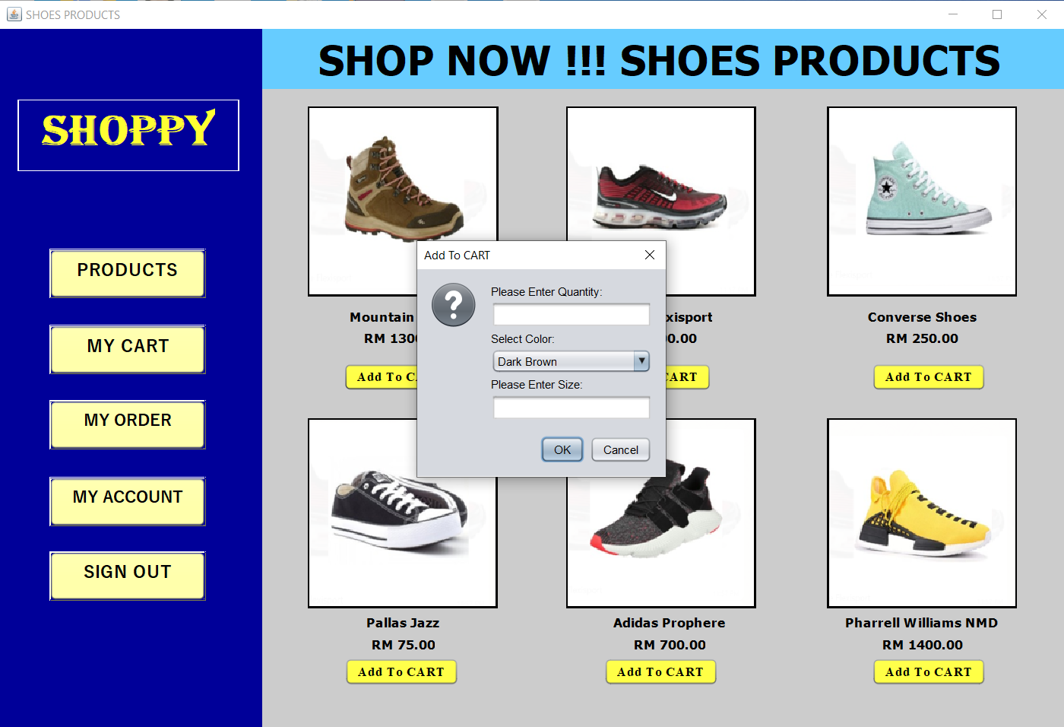

**Frame 16:**

When user click “JEWERELLY” button in the categories frame, the catalogue of Jewerelly products frame will show.

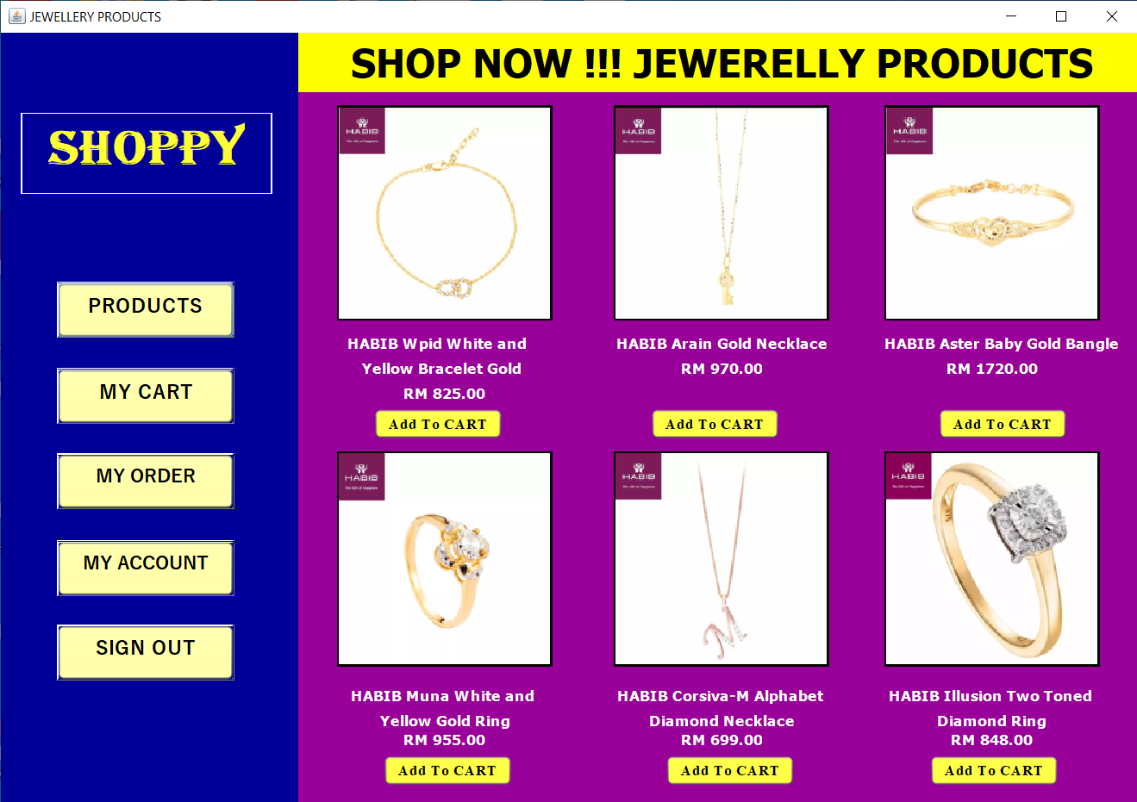

User can click “Add To CART” to select the Jewellery products. Then, user need to input quantity and click “OK” button.

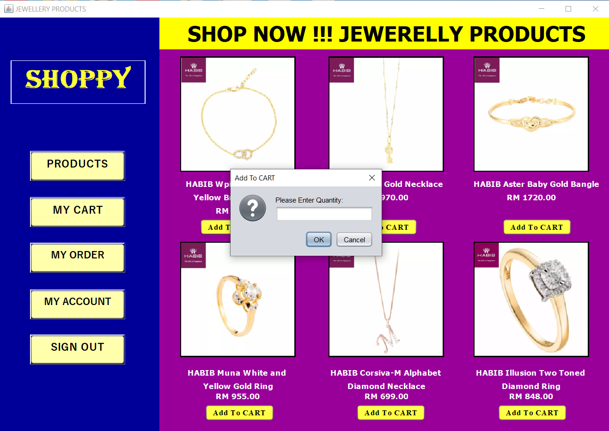

**Frame 17:**

When user click “CLOTHES” button in the categories frame, the catalogue of clothes products frame will show.

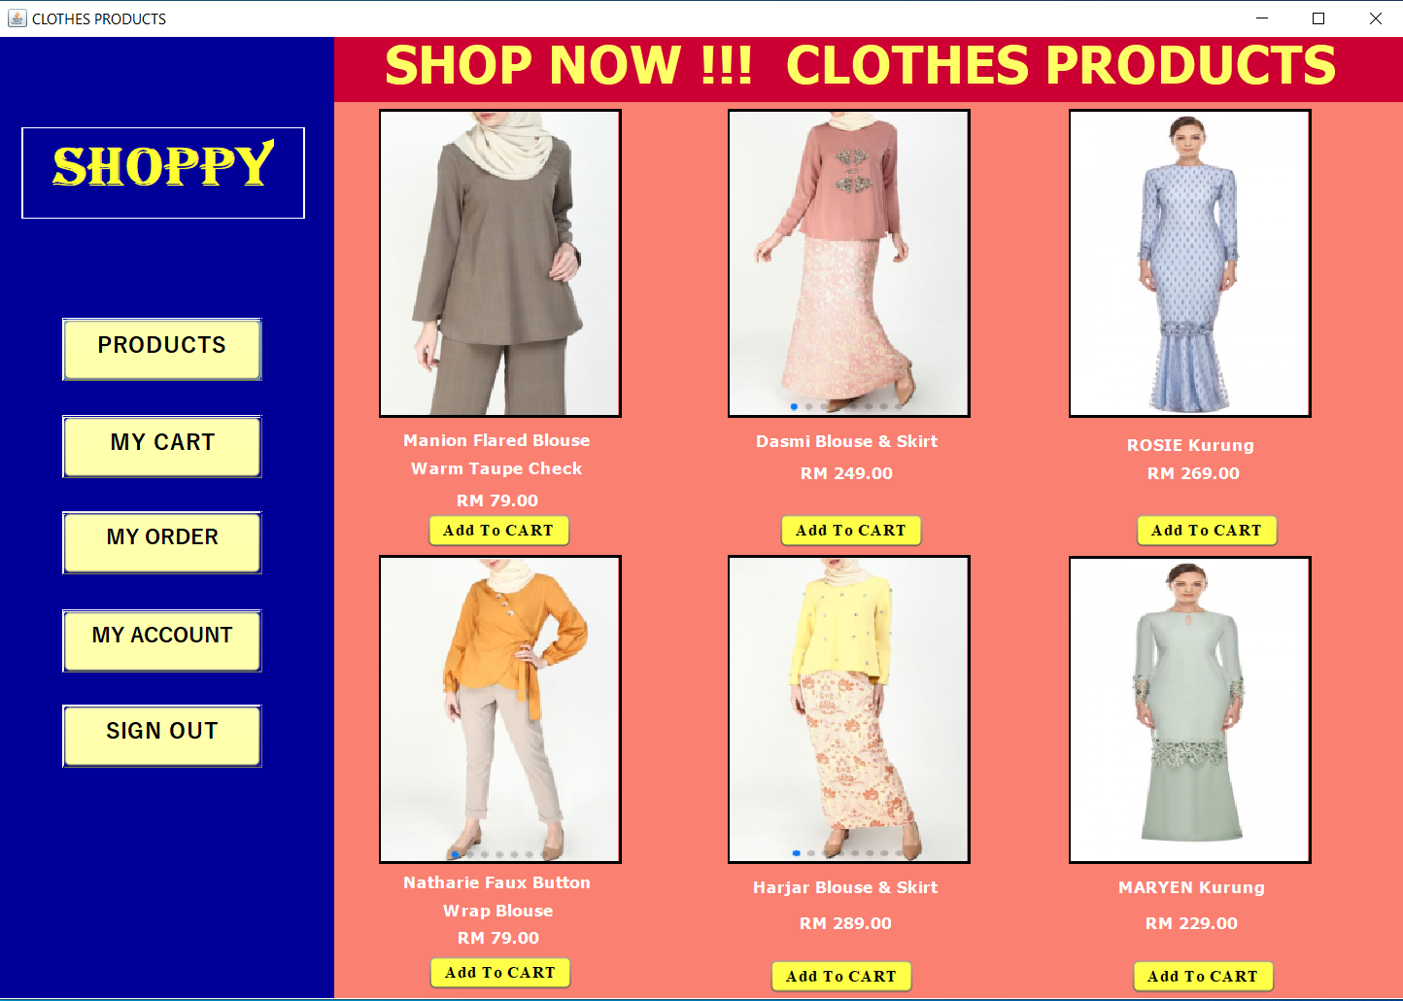

User can click “Add To CART” to select the Clothes products. Then, user need to input quantity, select color and click “OK” button.

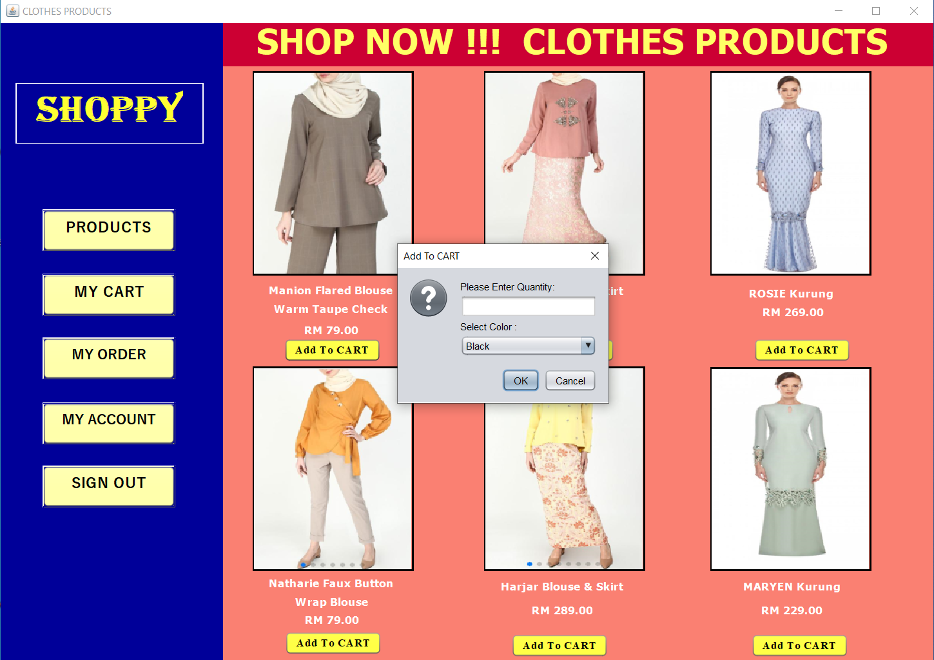

**Frame 18:**

When user click “MY CART” button, my shopping cart frame will show. User can add products again by click the “ADD Item” button and will go to the categories frame to view products.

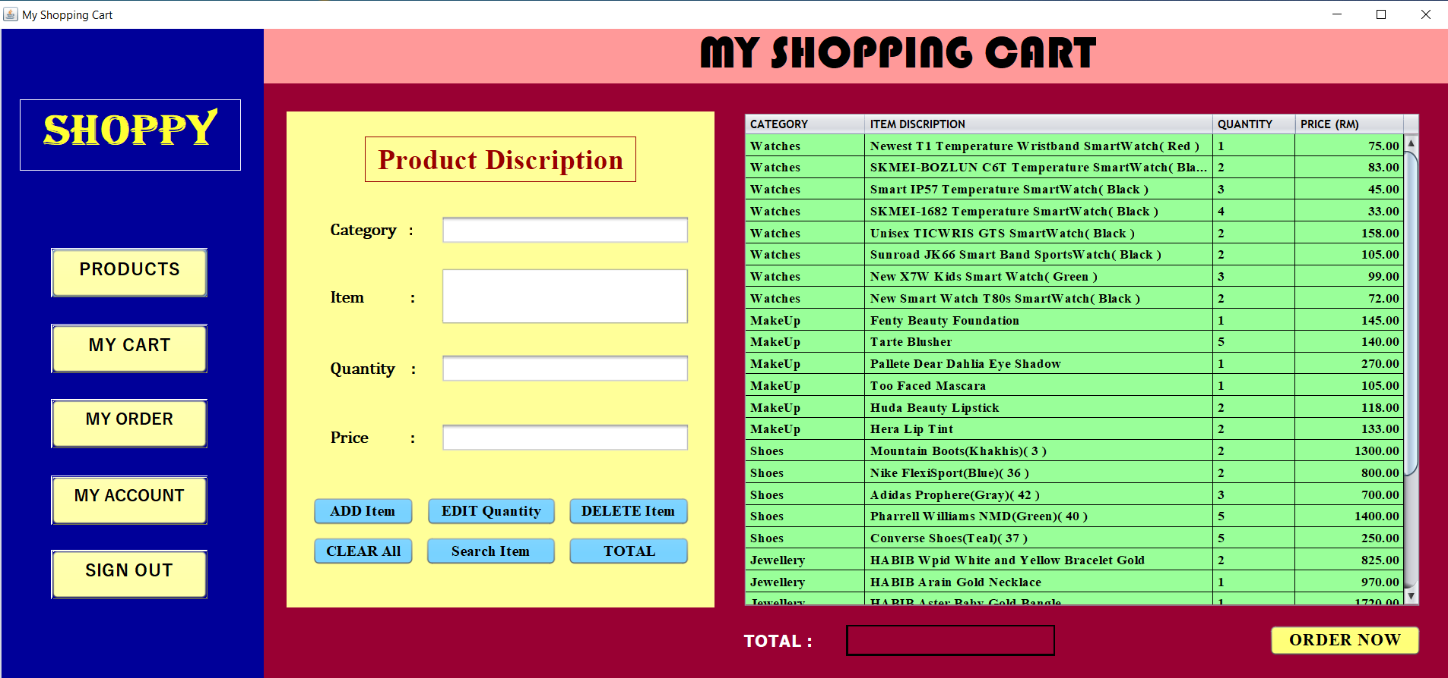

User can check the products have added in the table.

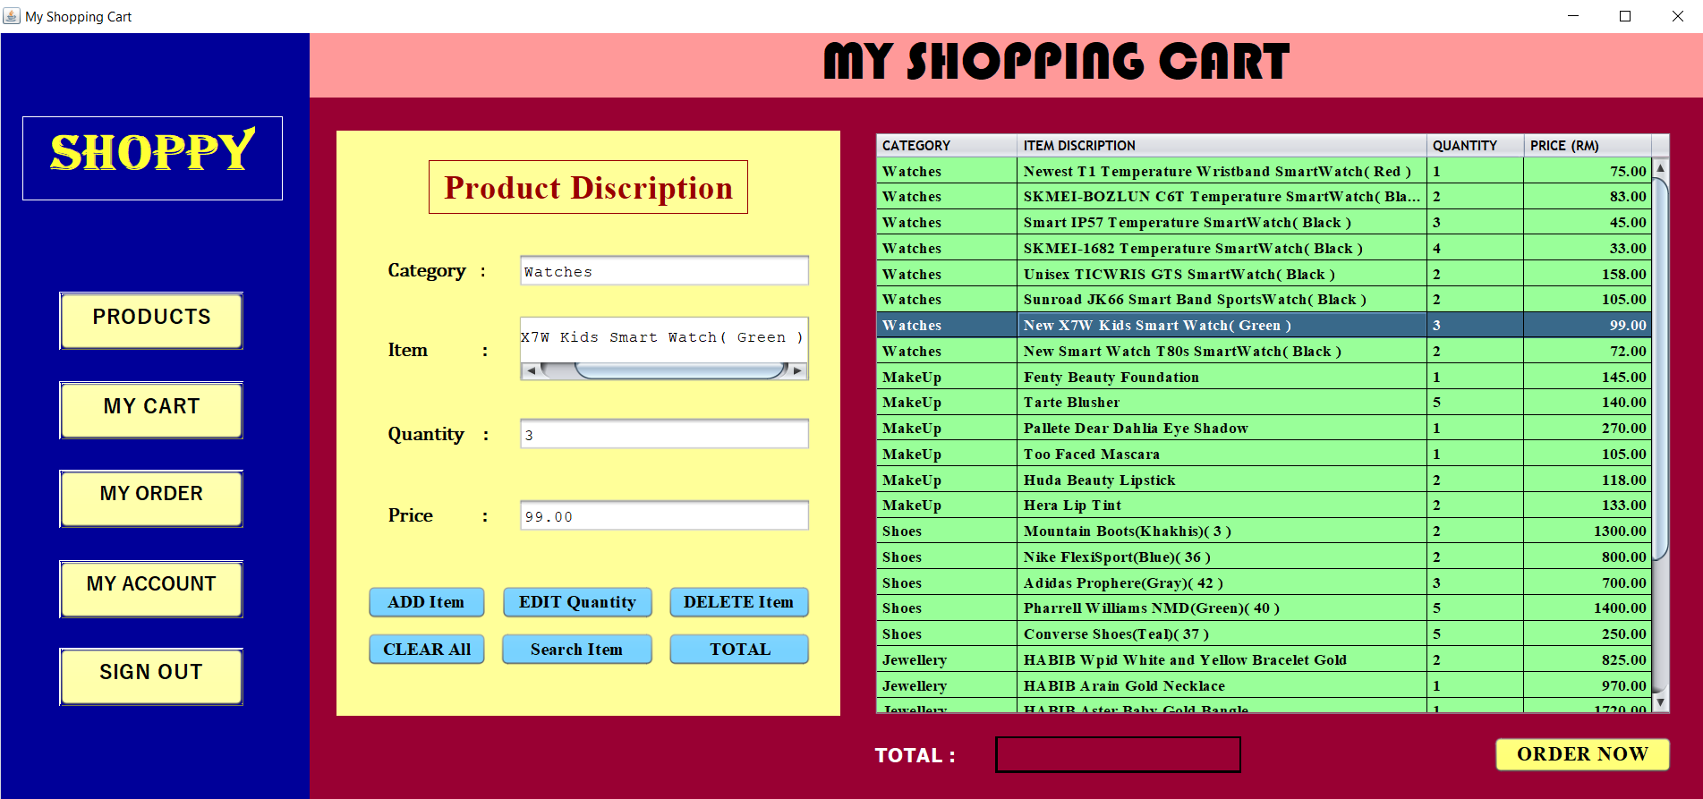

User can only edit quantity for the products have added. After user input the new quantity number, user need to click “EDIT Quantity” button.

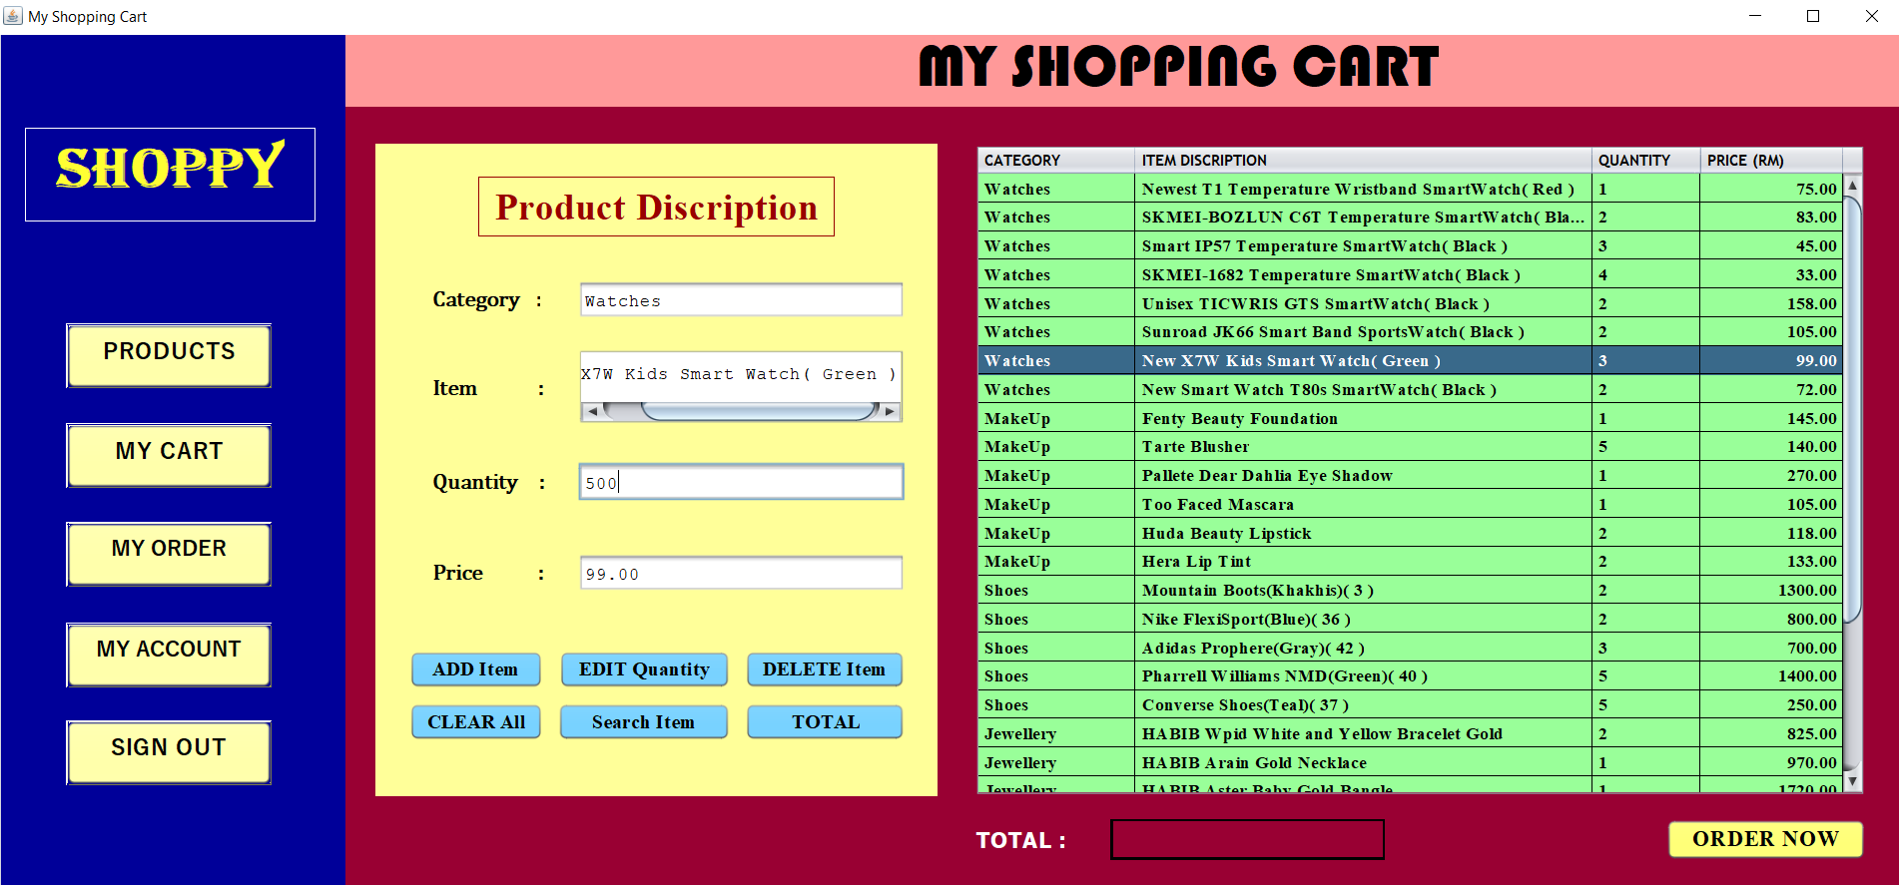

Then, the number of quantity is successful edited.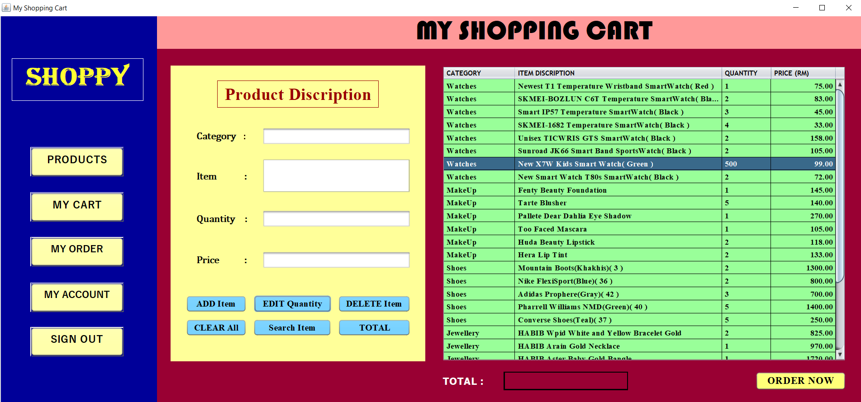

User can delete products that have added. User need to click on the table and select the delete item.

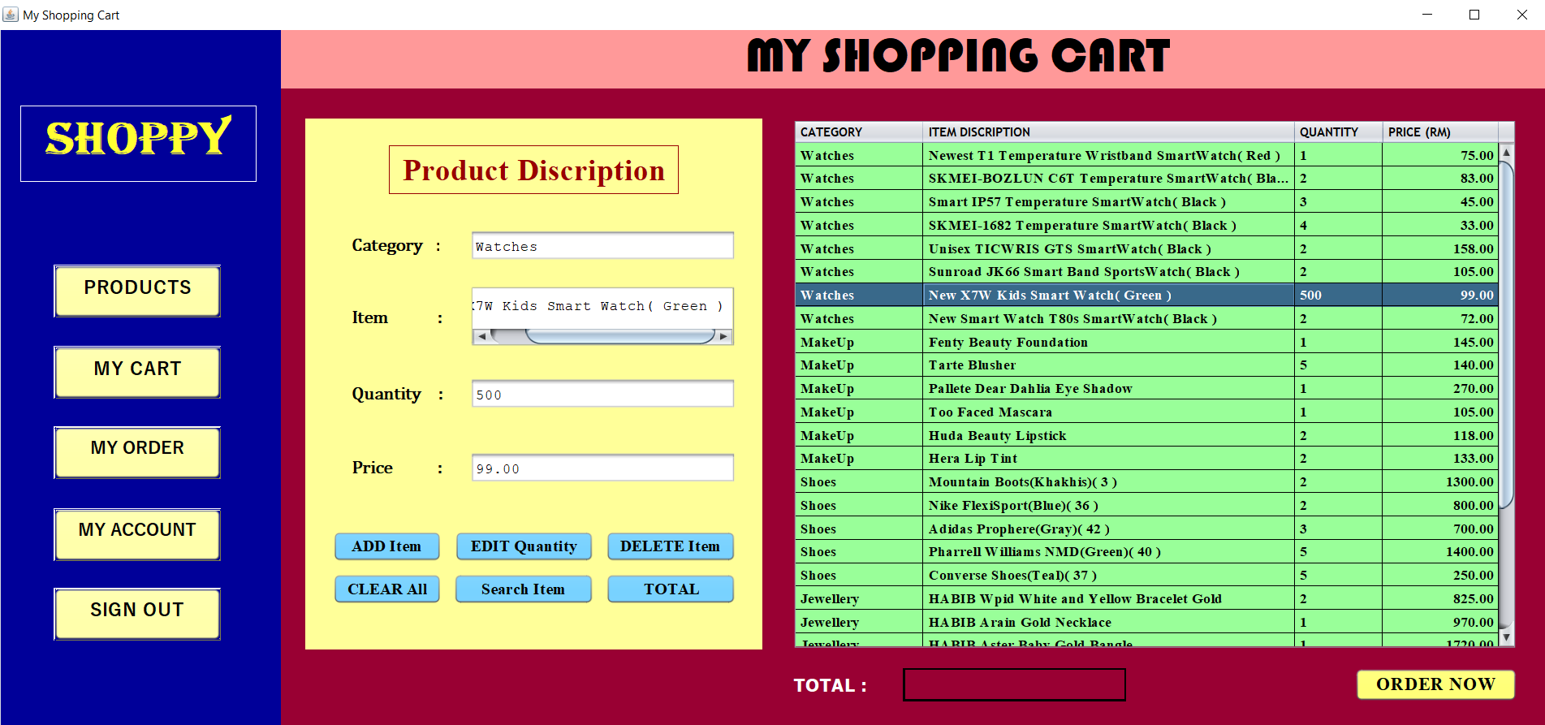

Then, click “DELETE Item” button. User will get a message to confirm delete.

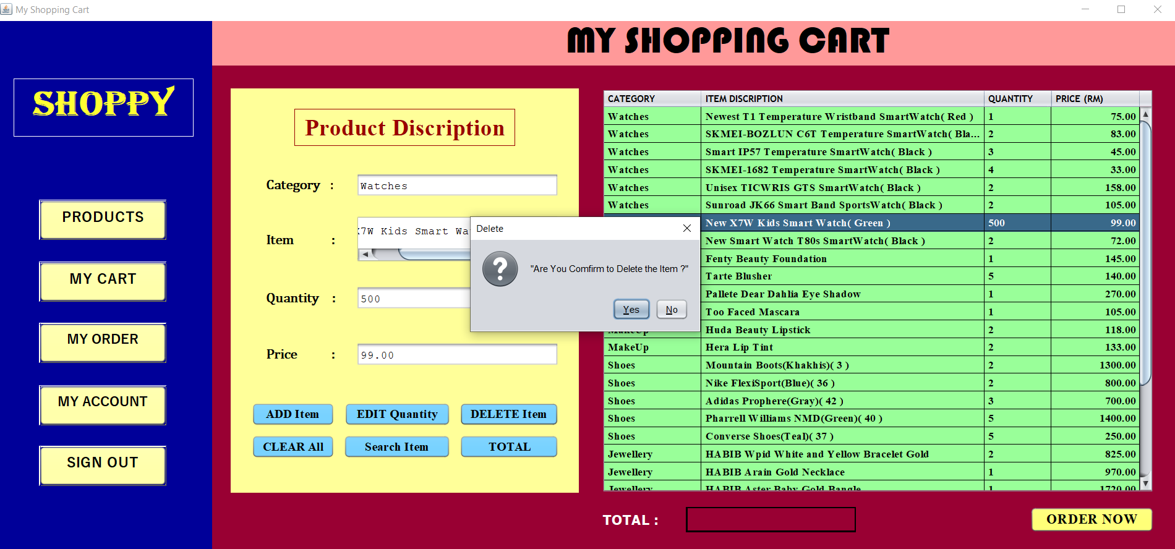

User can also search products by categories. User can click “Search Item” button.

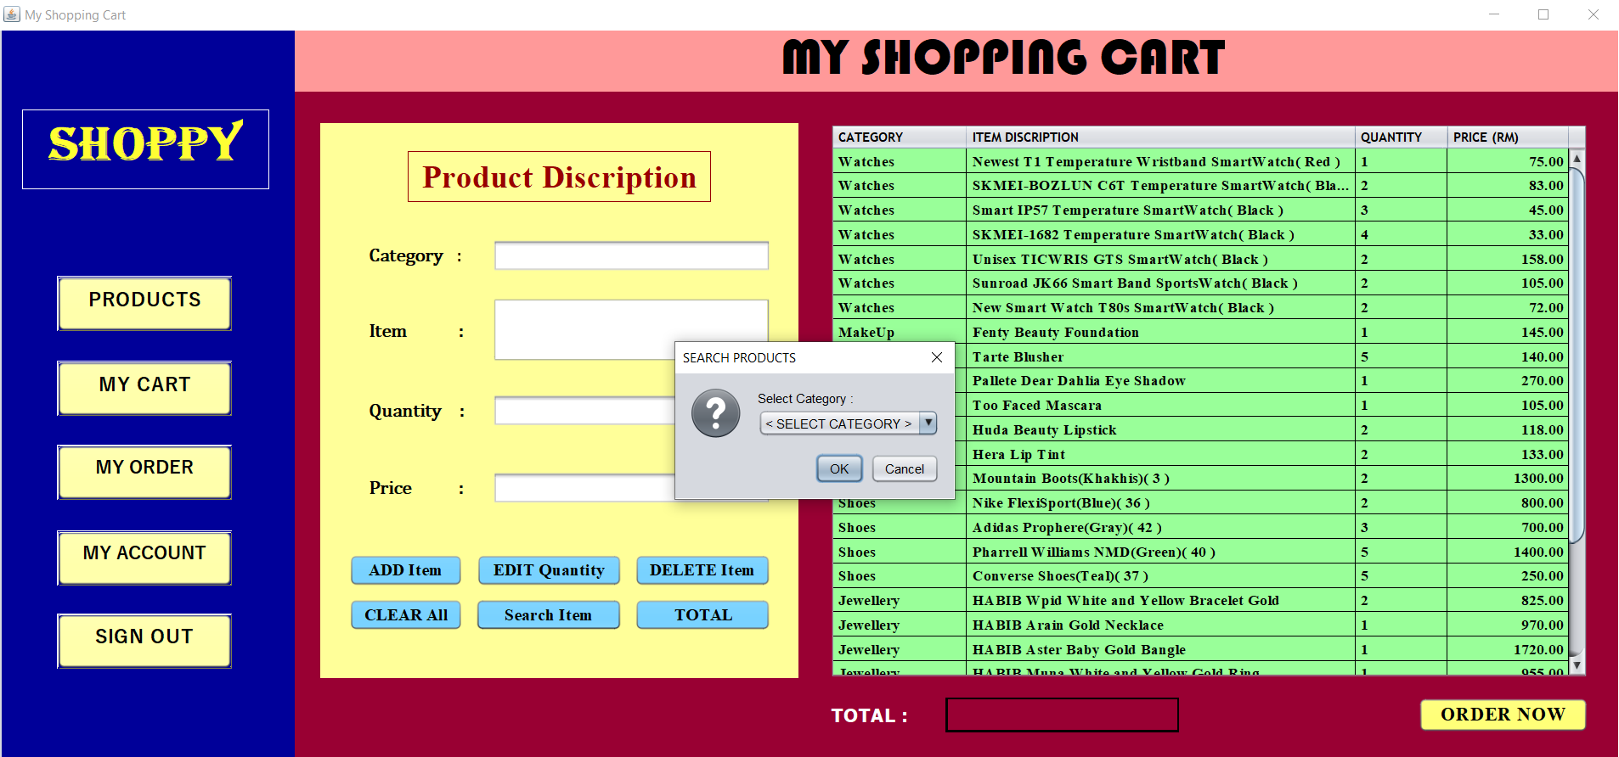

User need to select category and click “OK” button to search the item in the category.

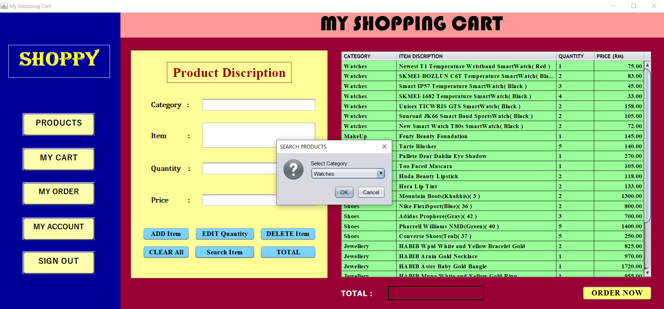

After that, will show the search result. It will show all the item in the category. There is show found no.1 and the details of products.

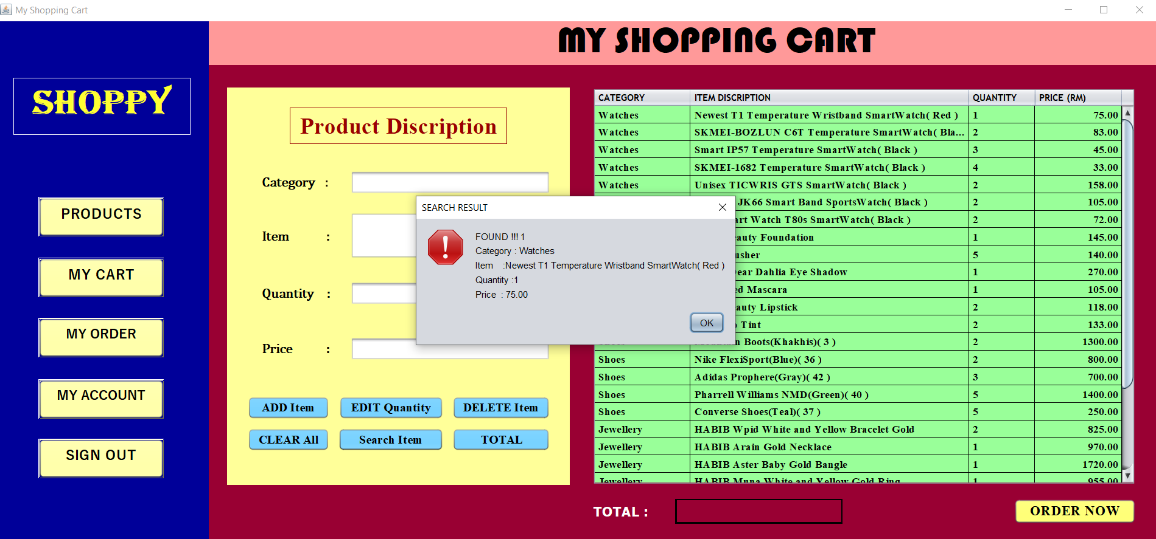

Next, found no.2 and details of products.

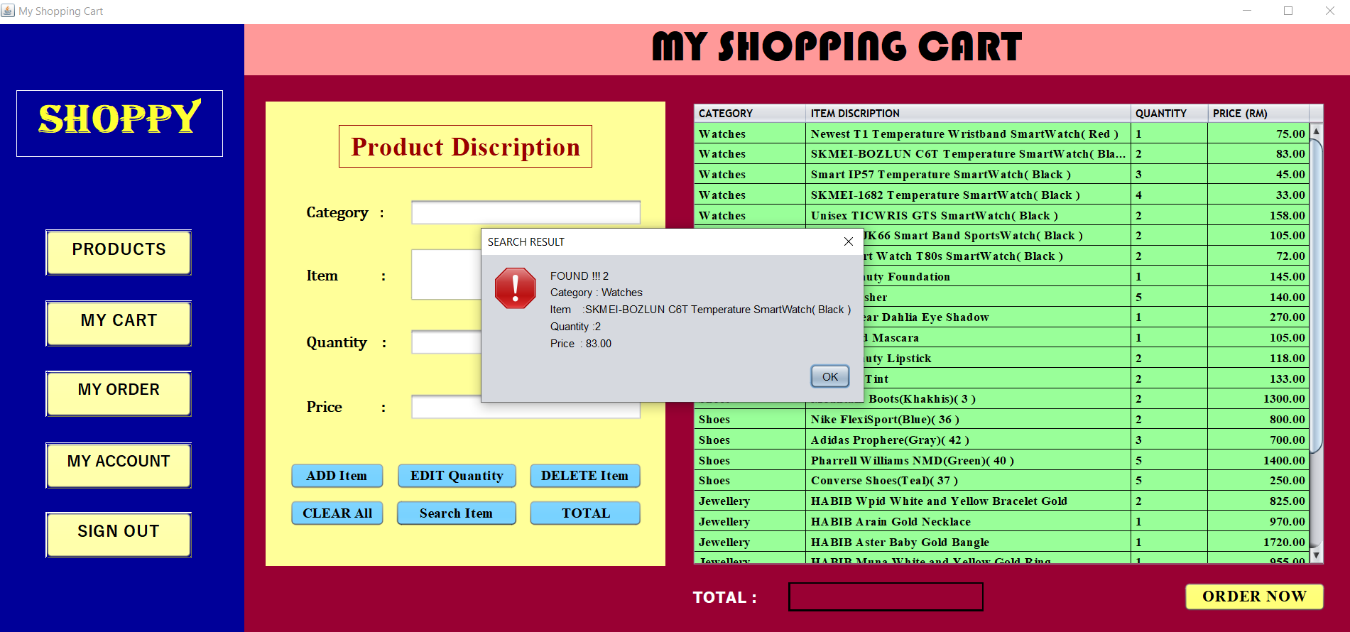

Next, found no.3 and details of products.

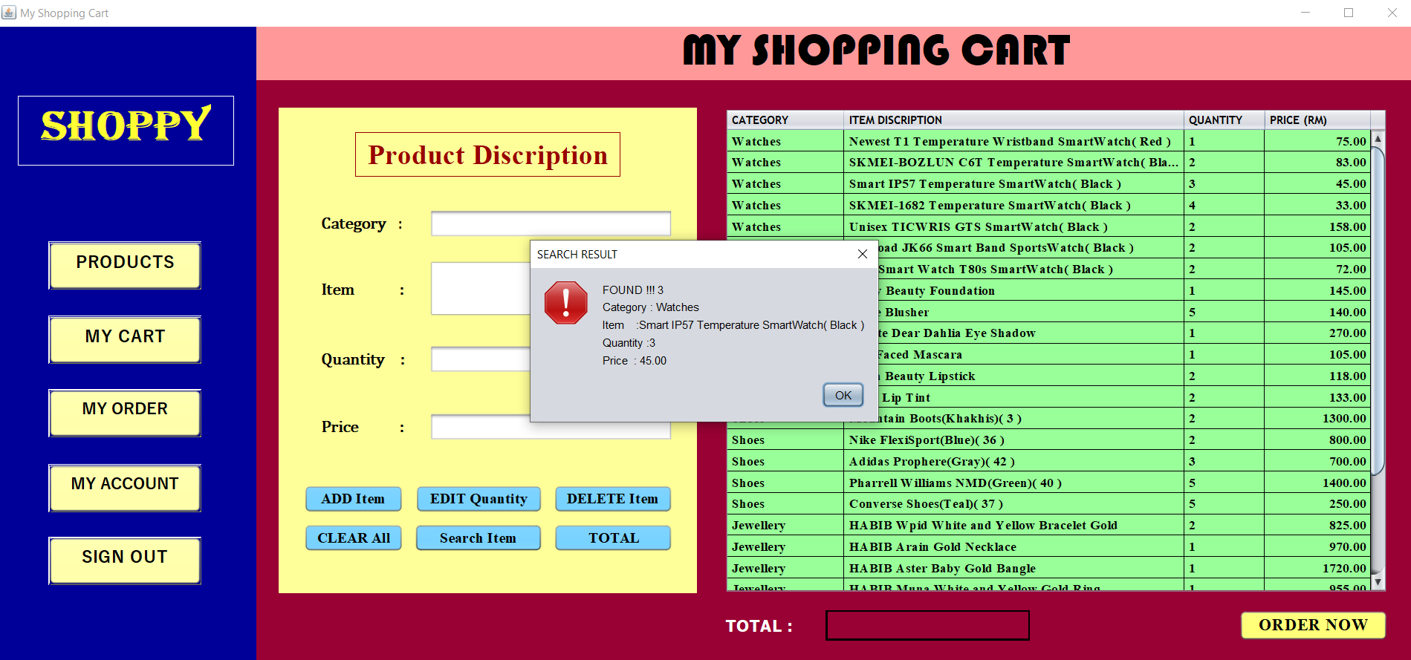

Next, found no.4 and details of products.

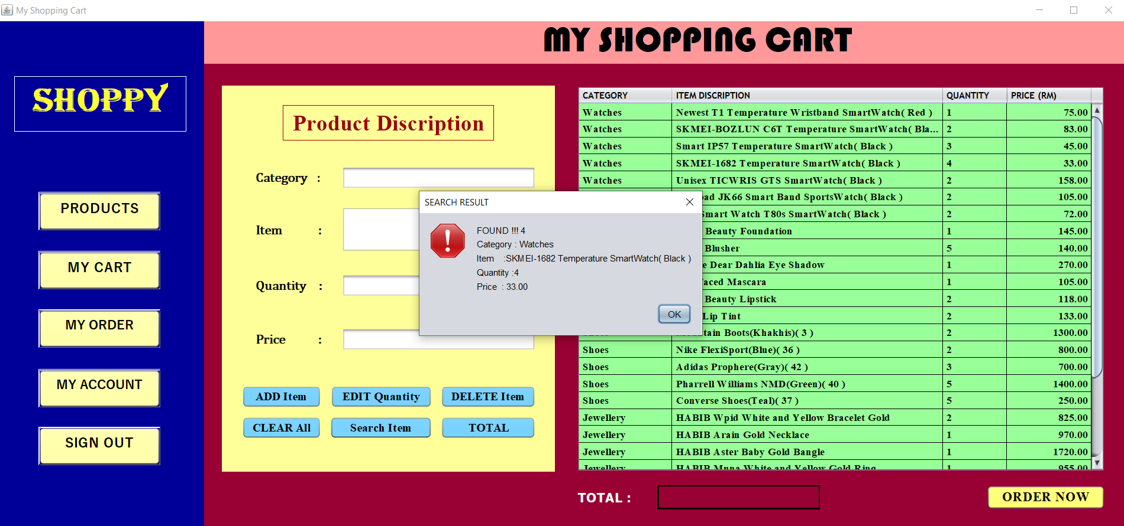

Next, found no.5 and details of products.

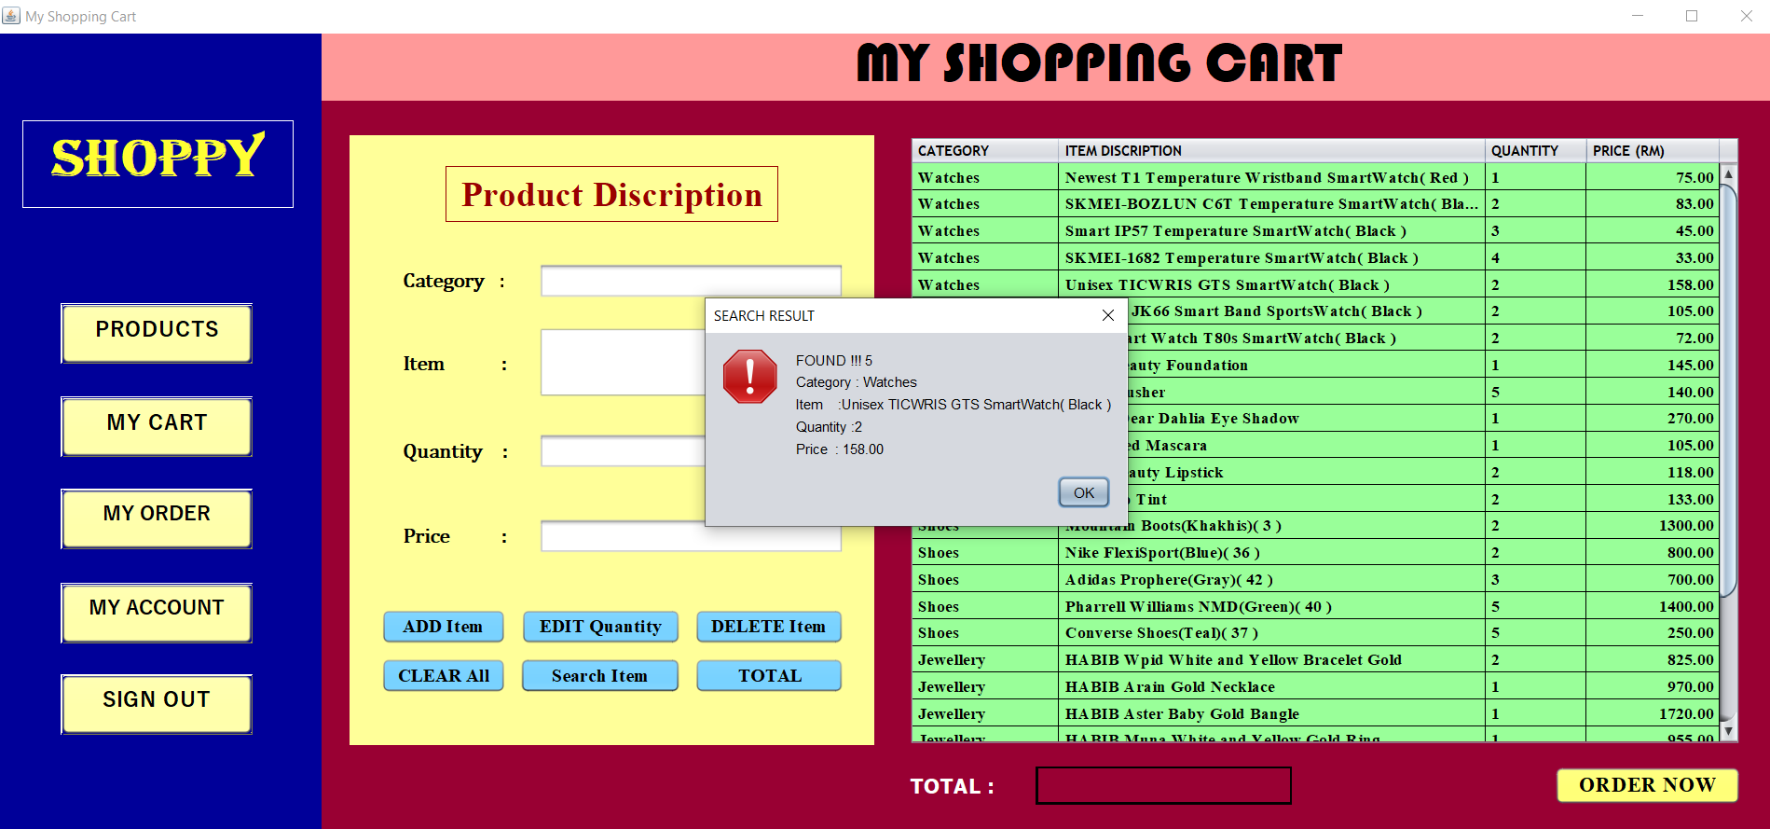

User can click “TOTAL” button to know the total price of products have added.

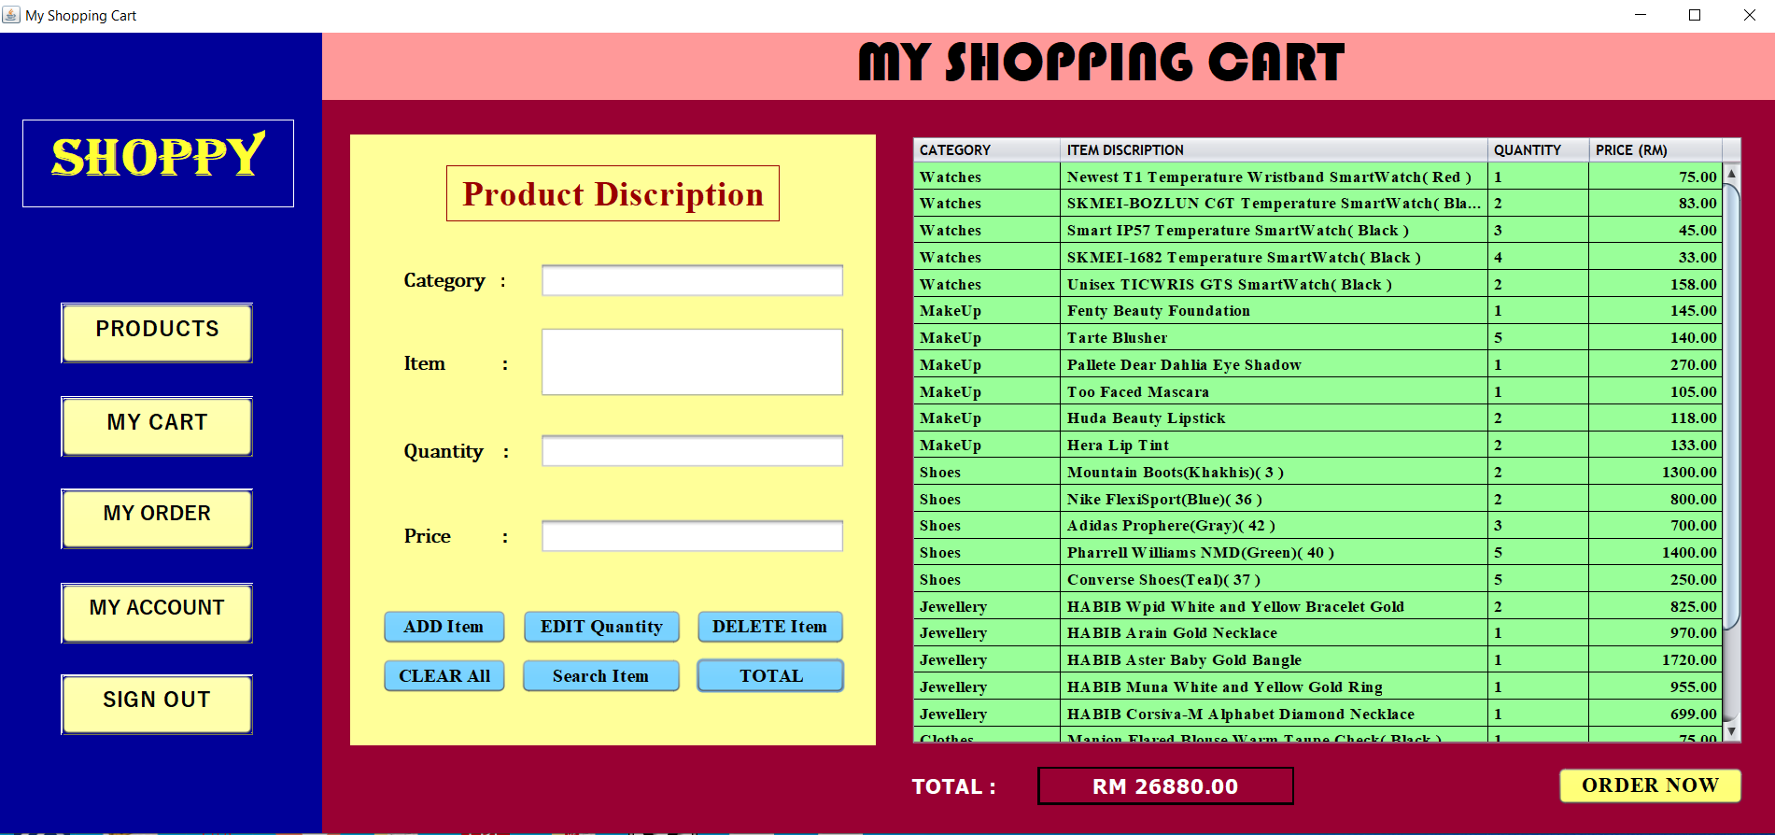

When user click “CLEAR All” button, all the products have added will be deleted and the table will become empty.

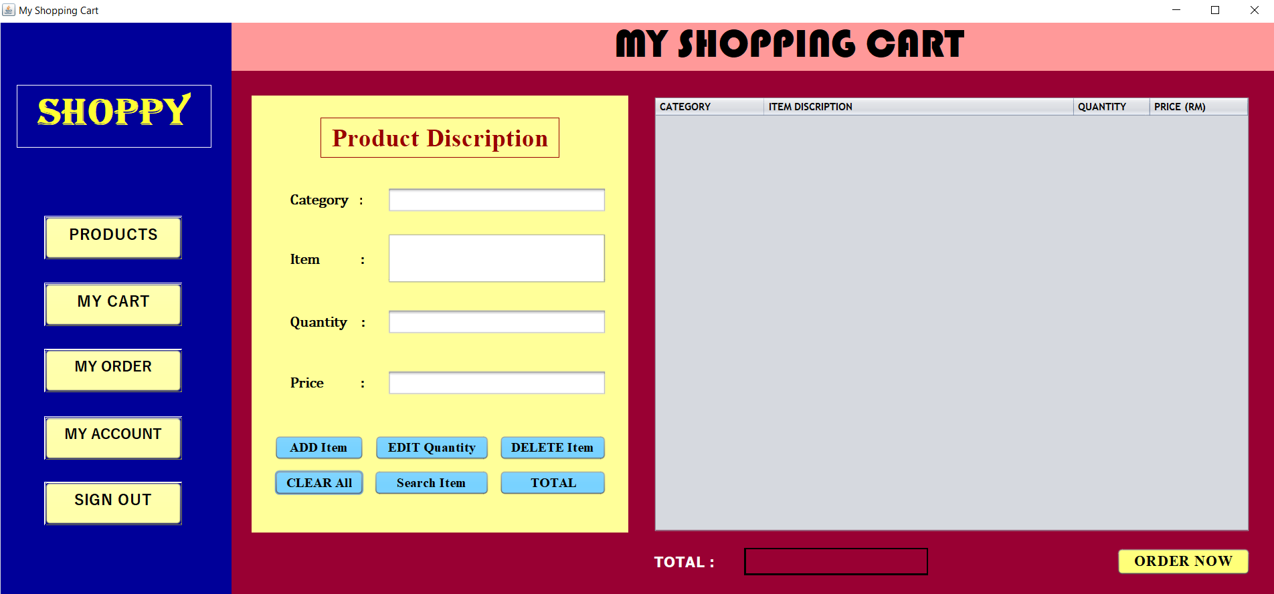

User can click “ORDER NOW” button to order the products have added. Then, it will show a message and need user to confirm order.

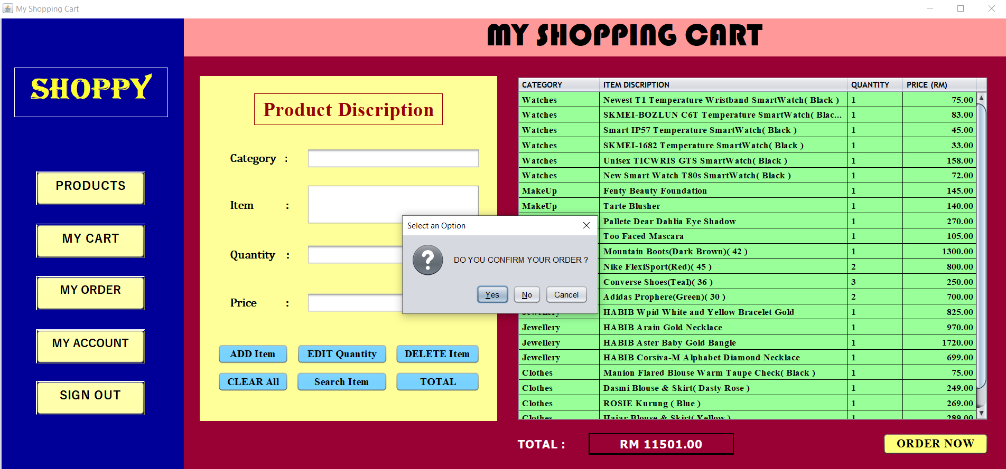

After confirm order and click “YES” button, it will show a Successful message. Then, user need to click “MY ORDER” button to get receipt.

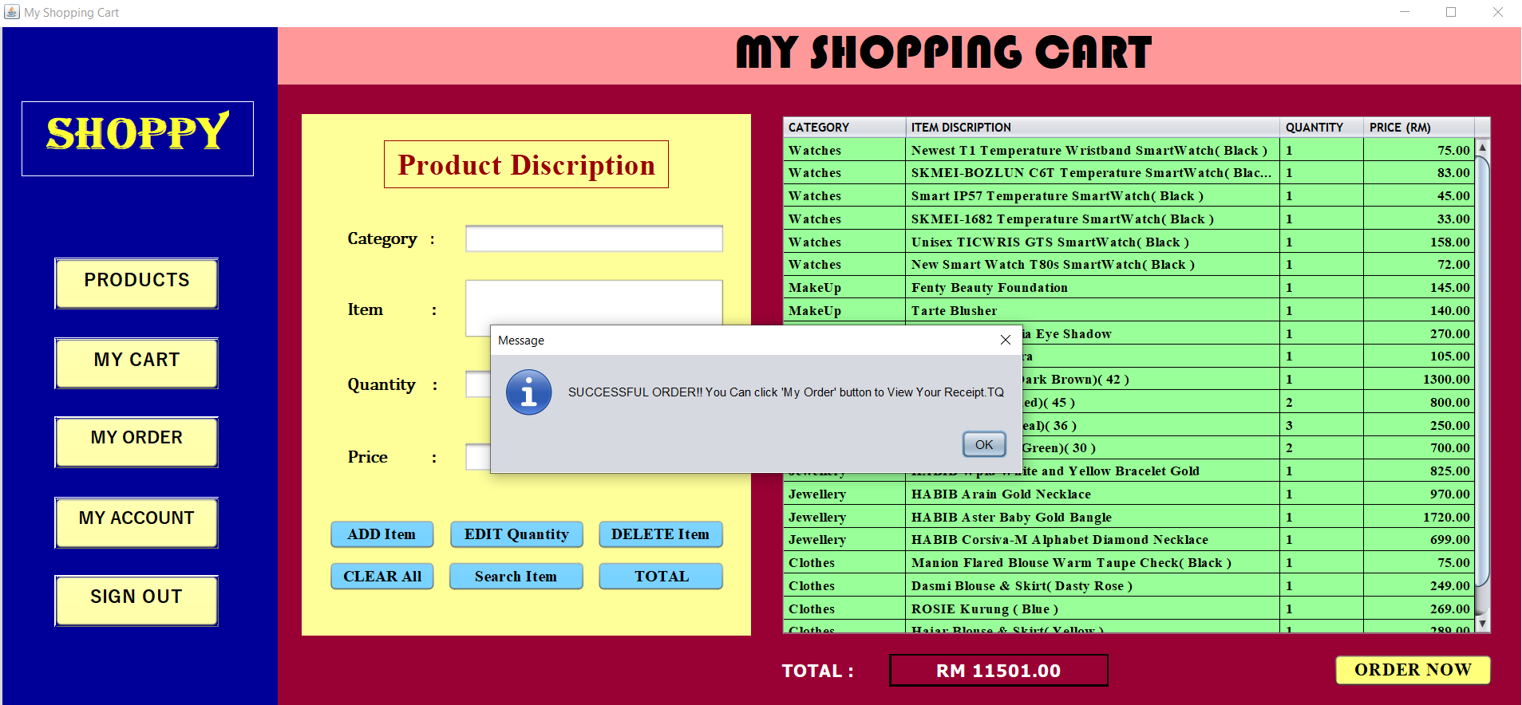

**Frame 19:**

This is the frame to show the order receipt.

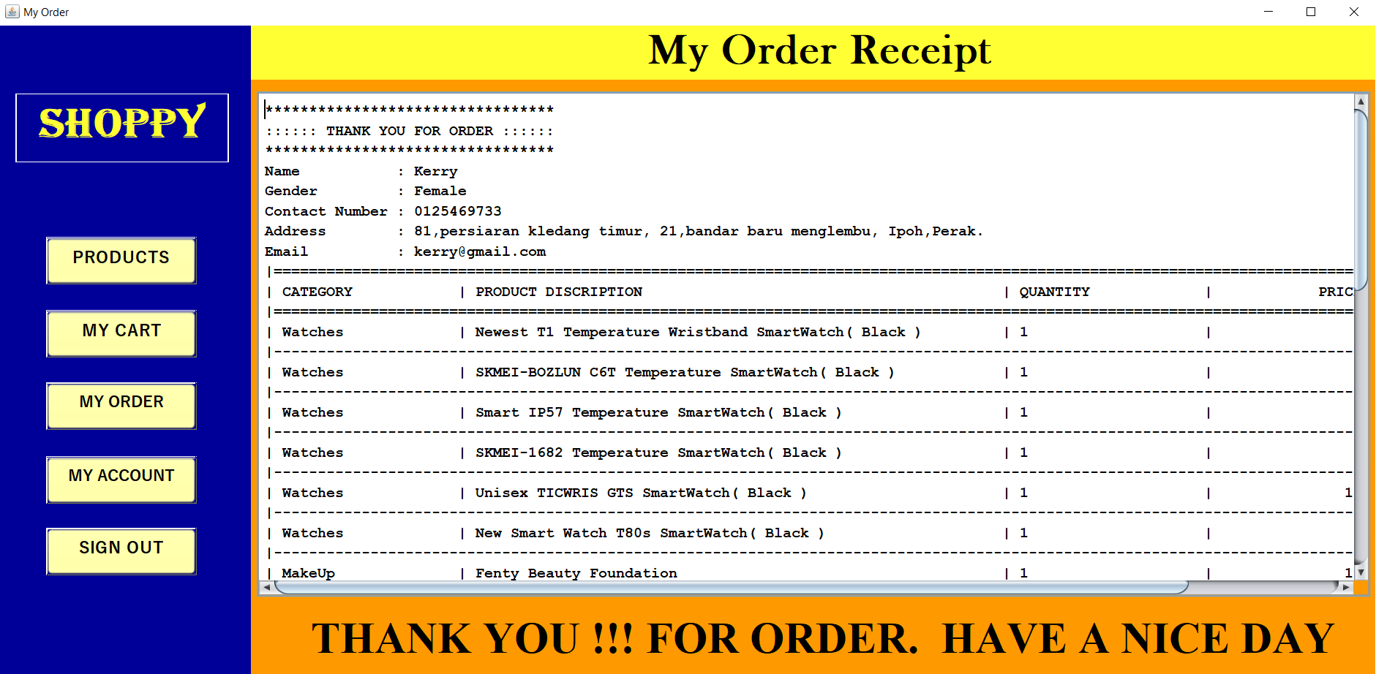

**Frame 20:**

When user click “MY ACCOUNT” button, user can see all their personal details.

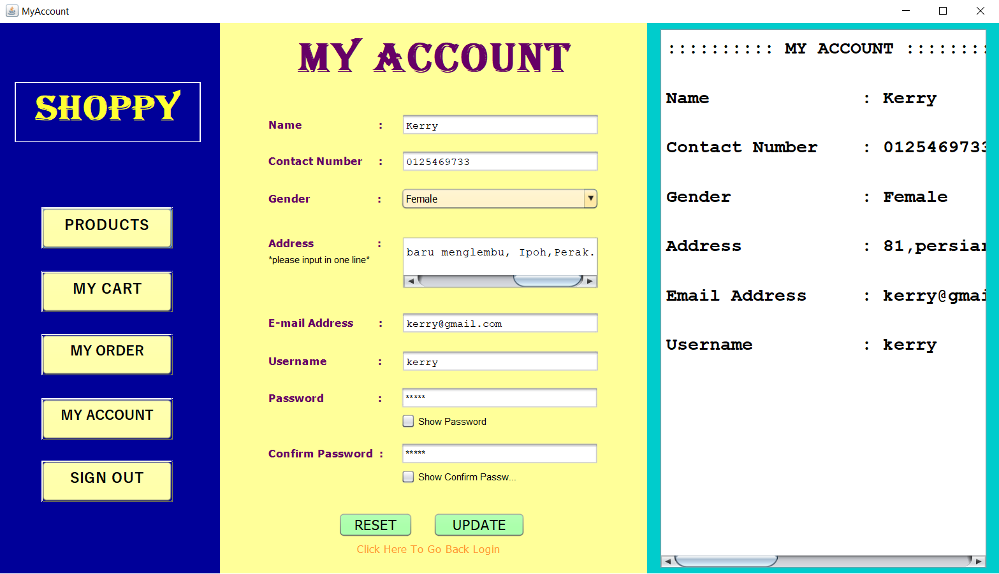

User can edit and update their details in the text field and click “UPDATE” button.

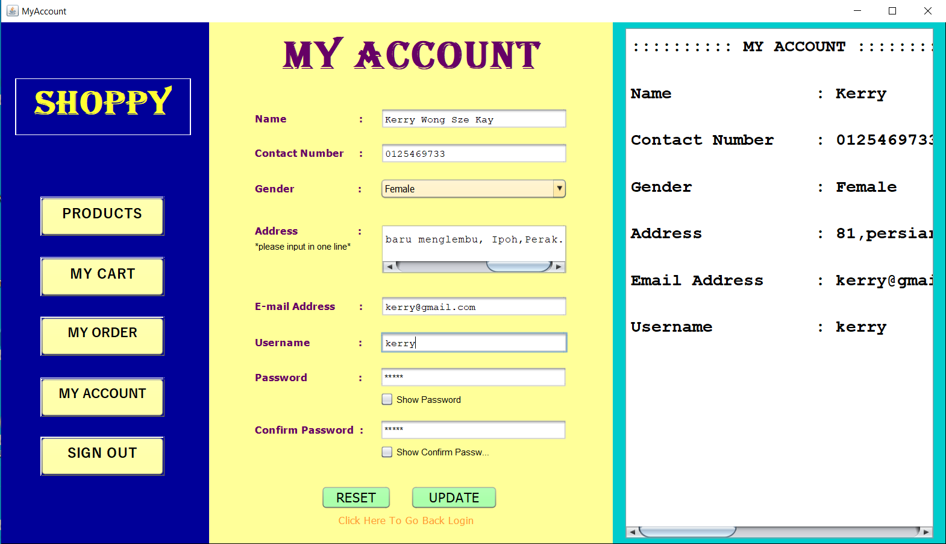

User need to check their update details and confirm to update.

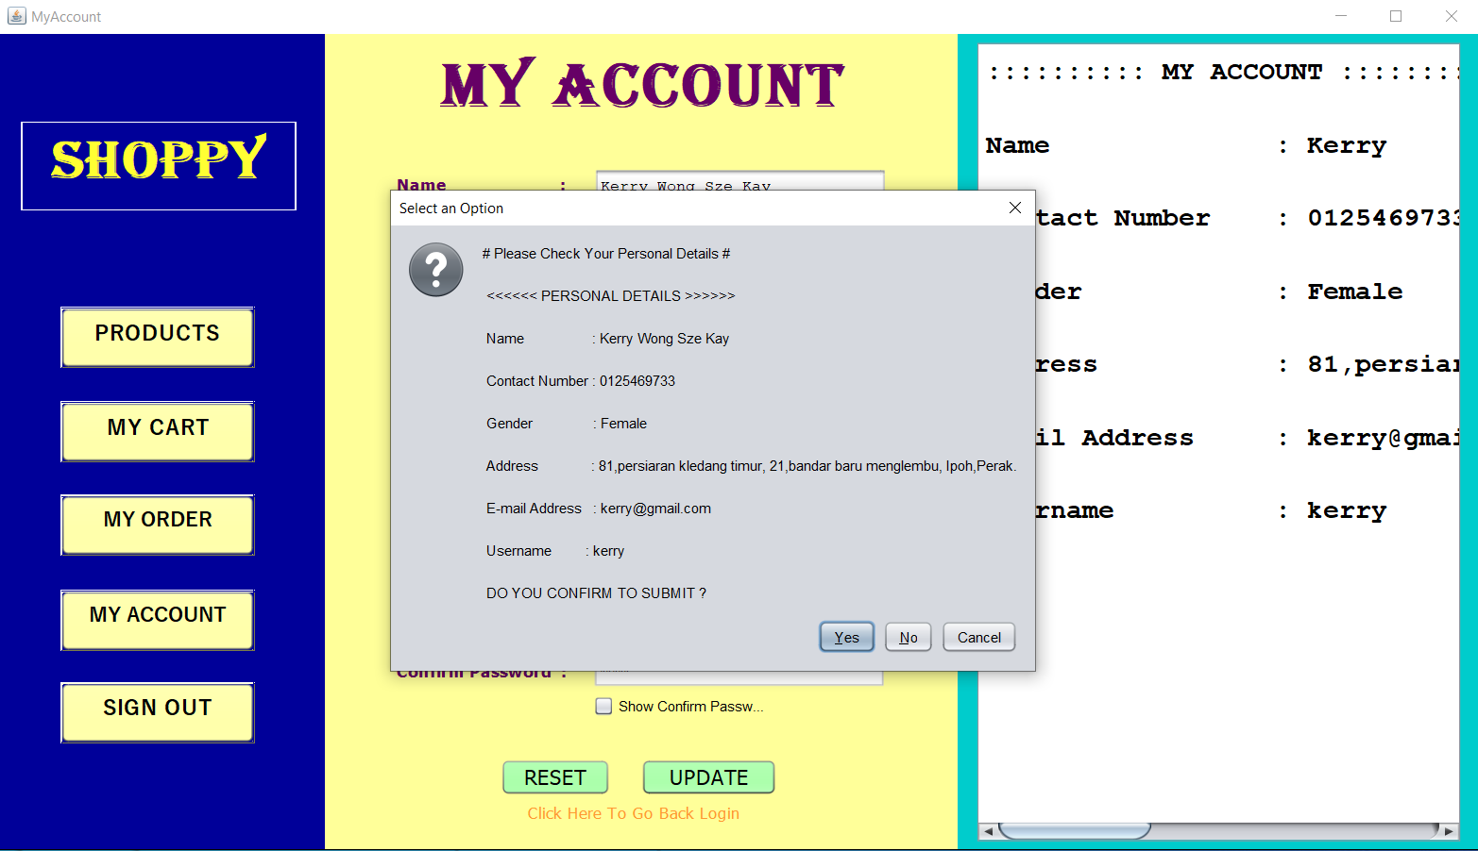

After confirm and click “YES” button, it will show a message “UPDATE SUCCESSFUL!!!”

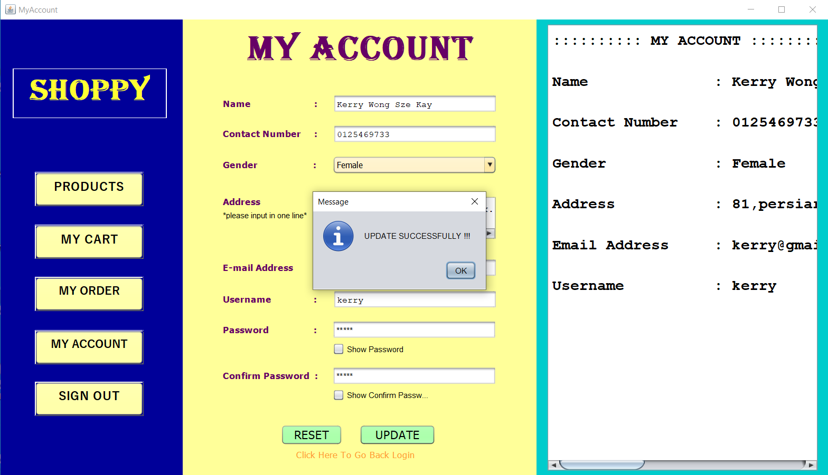

The text area will also update the details.

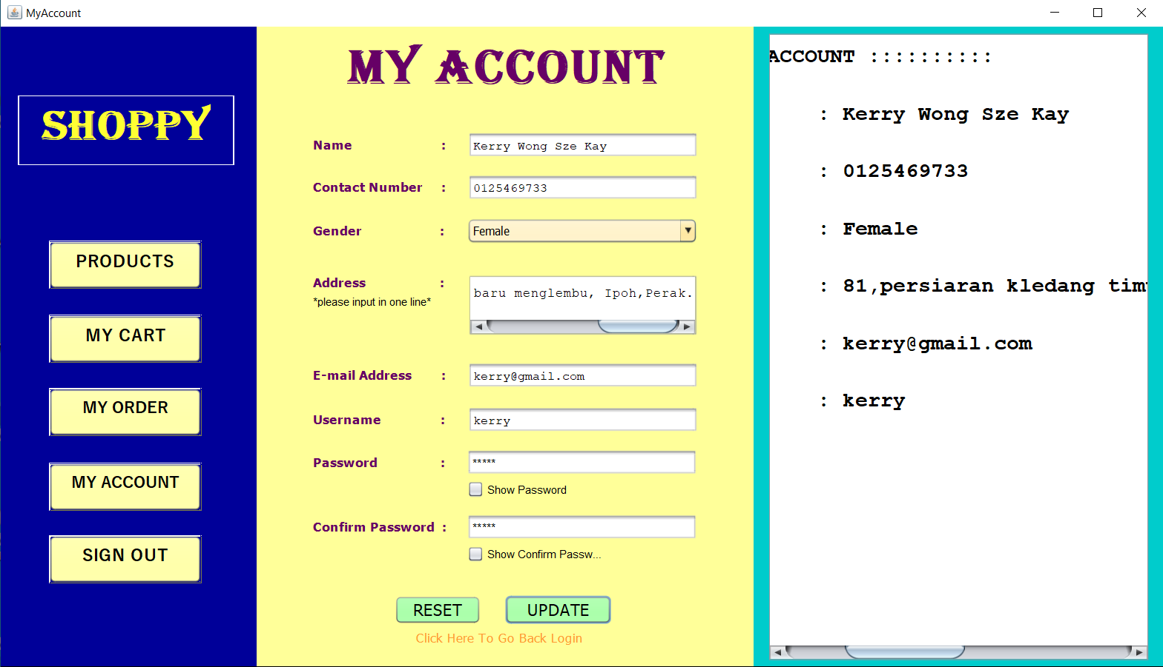

When user click “SIGN OUT” button, user need to select an option to confirm sign out account.

